Work Diary Contents

17/10/2022: 1

20/10/2022: 1

27/10/2022: 2

01/11/2022: 2

02/11/2022: 2

03/11/2022: 3

04/11/2022: 4

07/11/2022: 5

08/11/2022: 5

09/11/2022: 5

10/11/2022: 7

11/11/2022: 7

14/11/2022: 8

15/11/2022: 10

16/11/2022: 11

17/11/2022: 11

18/11/2022: 12

21/11/2022: 12

22/11/2022: 13

23/11/2022: 14

24/11/2022: 14

25/11/2022: 14

### 17/10/2022:

I have some basic code which can read a classical many-body spin state into a string and read it back as a vector. The only problem is it drops zero states; this was fixed with the addition of an extra site in the 1 state which is then dropped in later steps.

In the afternoon, I read the paper “MBL and Thermalisation in Quantum Stat. Mech” to get some more background on Quantum Thermalisation, ETH and Anderson Localisation. I have some handwritten notes summarising key points from this.

### 20/10/2022:

The last few days consisted of learning some content from the maths module and doing some more reading around ETH. Now, I’ll try and apply what I’ve been reading and do Exact Diagonalisation (ED) on a Hamiltonian. One such package is QuantumLattices: [Home · QuantumLattices.jl (quantum-many-body.github.io)](https://quantum-many-body.github.io/QuantumLattices.jl/latest/)

In the afternoon, I read some of the documentation of this package and have a clearer idea on how to construct a Hamiltonian and perform ED.

### 27/10/2022:

The past few days have consisted of writing a code which constructs a Hamiltonian (the Tilted transverse field Ising model) from scratch which involves making the operators which act trivially on single spin sites.

### 01/11/2022:

Once I got a working Hamiltonian, I worked on diagonalising it to find eigenstates and then tried reproducing Figure 4.2 using my code. However, with larger system sizes you have far too many data points to reasonably plot, so I think I’ll try reducing it by plotting 1 in every 2^N/2 points maybe…

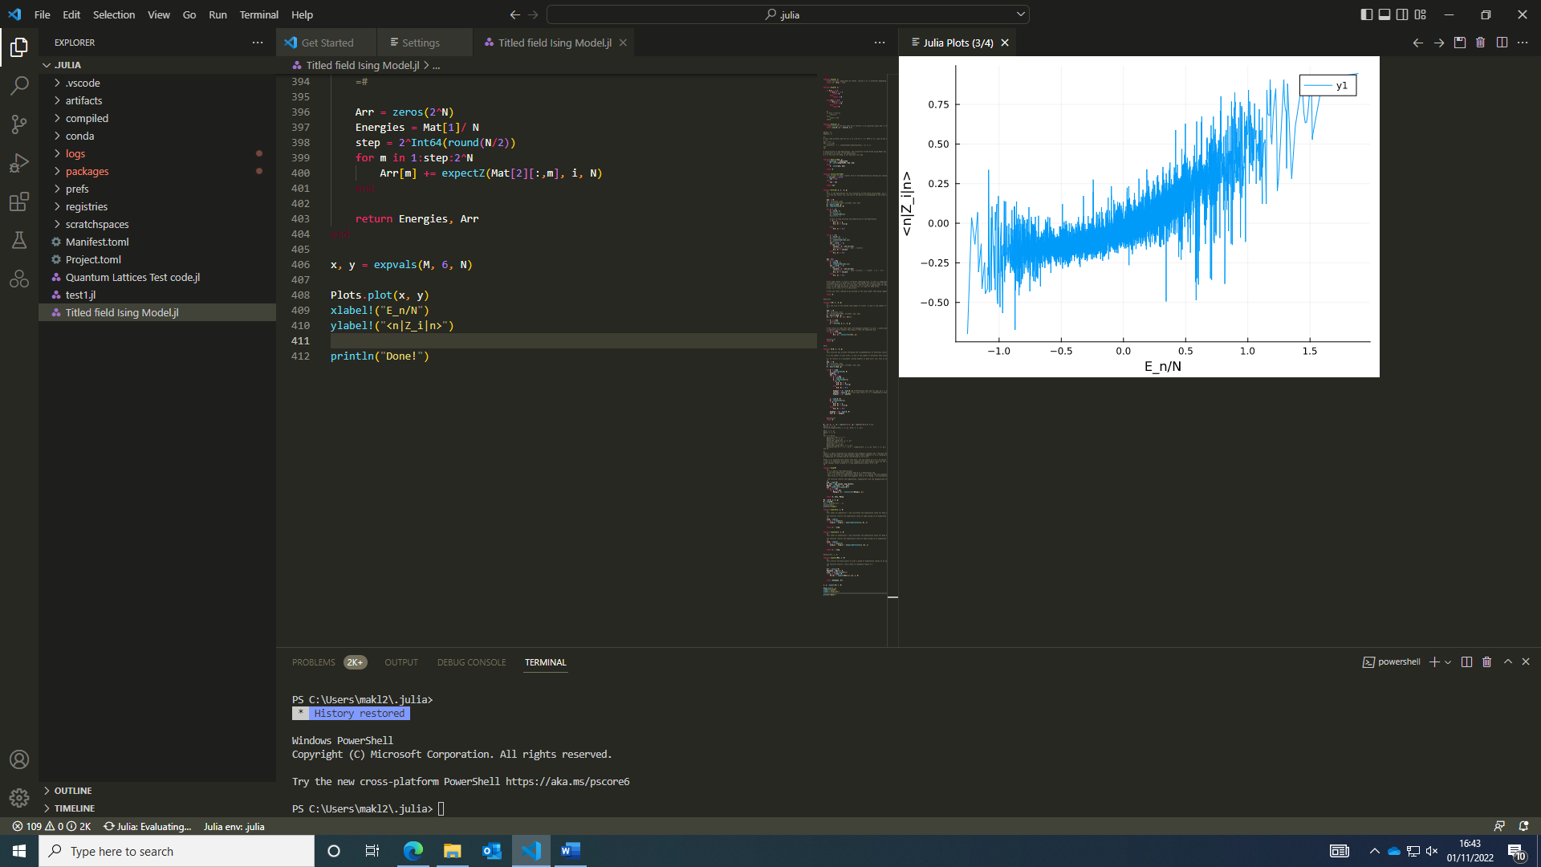The graphs produced were with Z for N = 10, 12, 13 and ZZ for N = 13 (operator had i = 3 however the choice of site is arbitrary due to translational symmetry of the system). This graph was a Z operator acting on 1 site for N = 13.

### 02/11/2022:

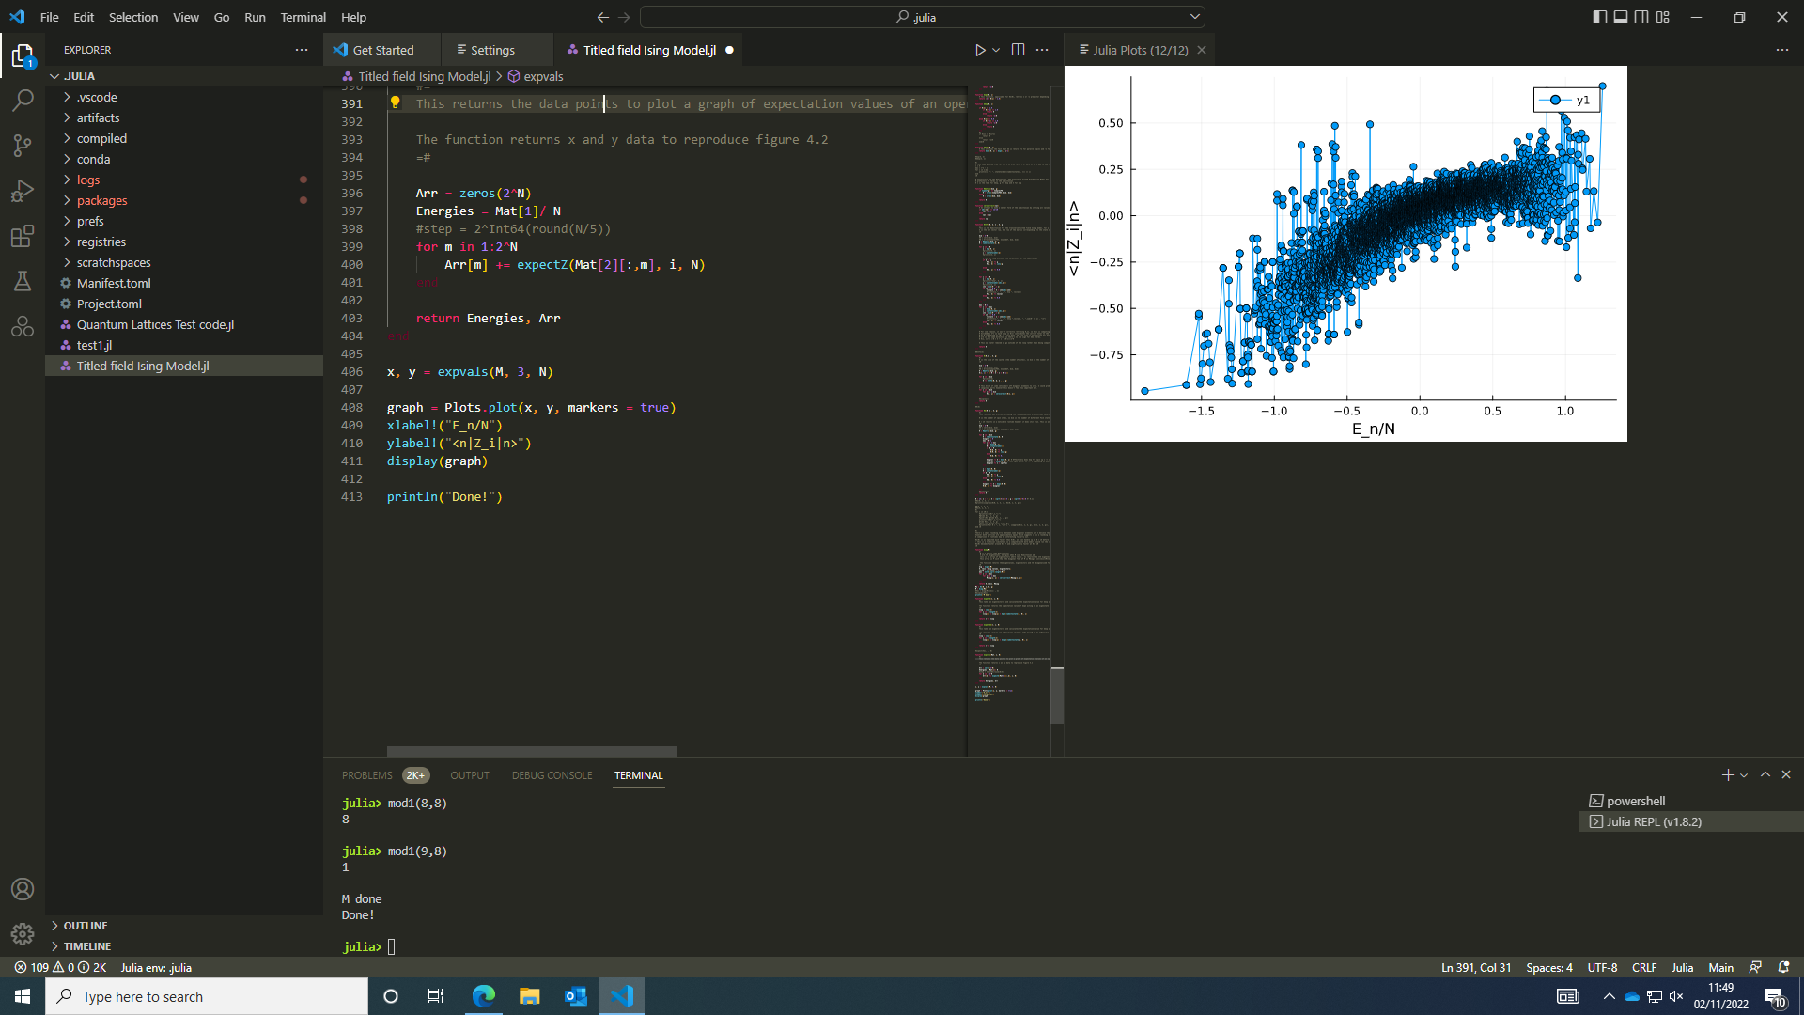This graph is also for N = 13 acting on a different site but with a different sign for J which produces a curve in the opposite direction, but the behaviour is otherwise similar. I ran this to check which sign they were using in the paper as it wasn’t obvious that J should be positive as that suggests parallel spins are higher in energy.

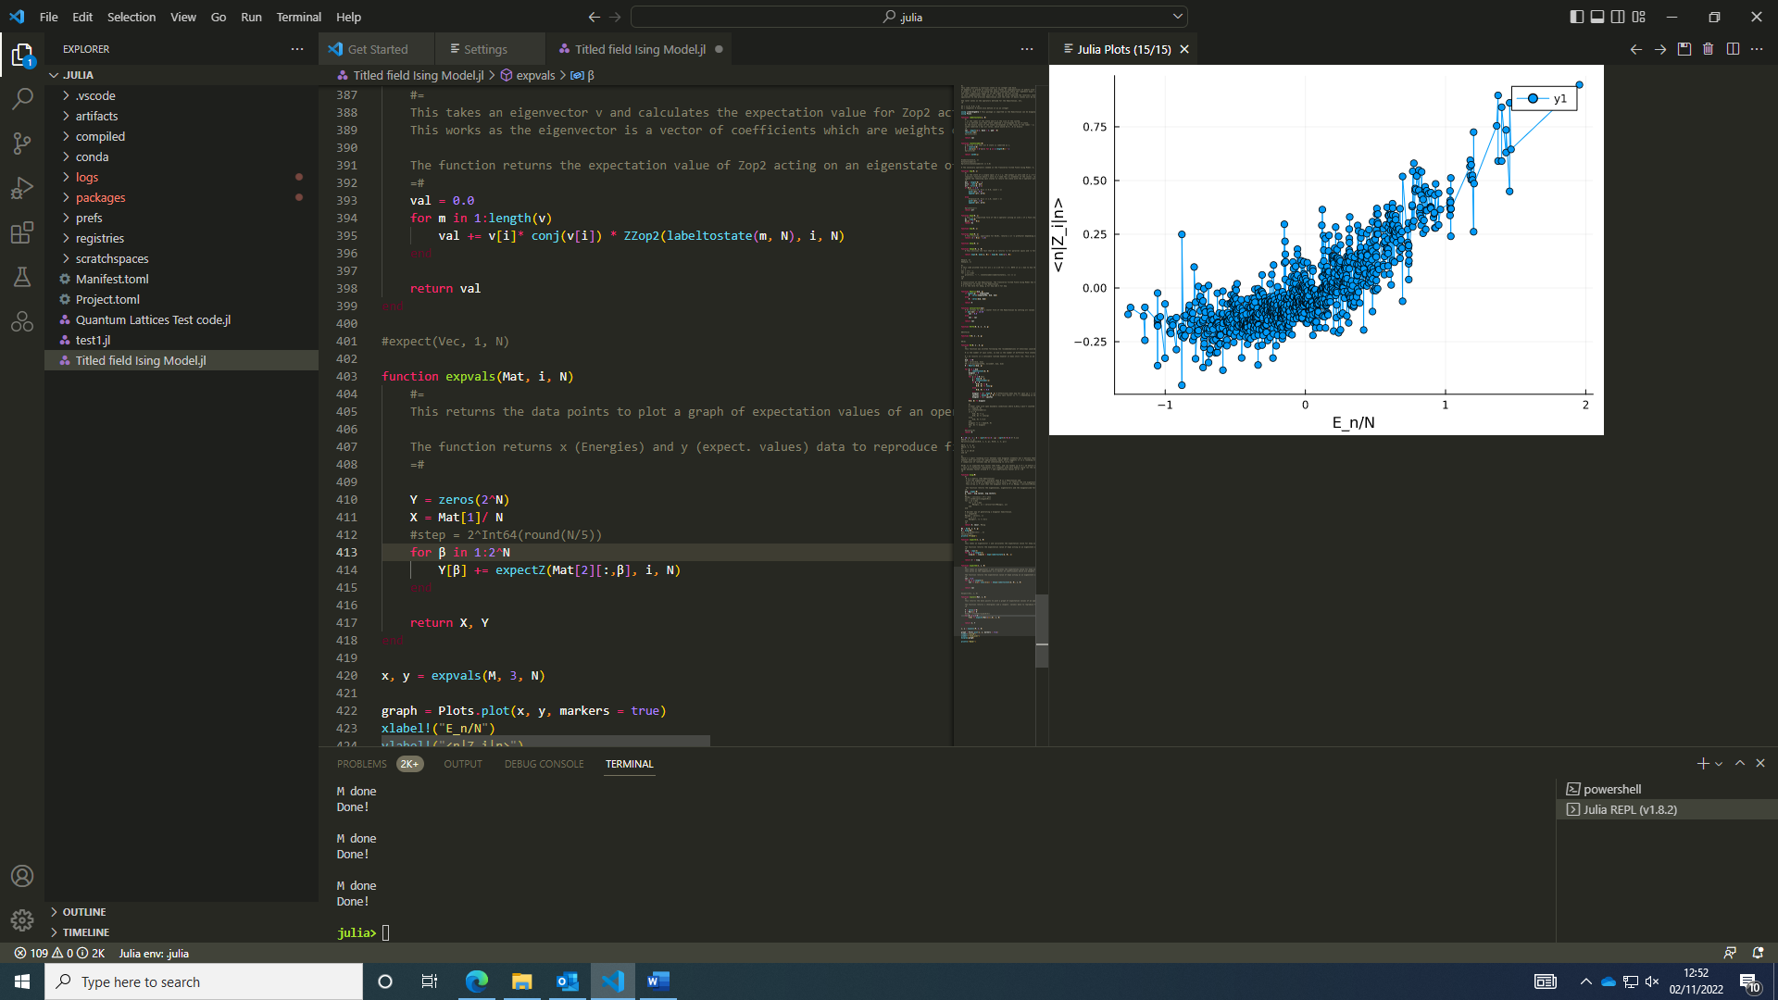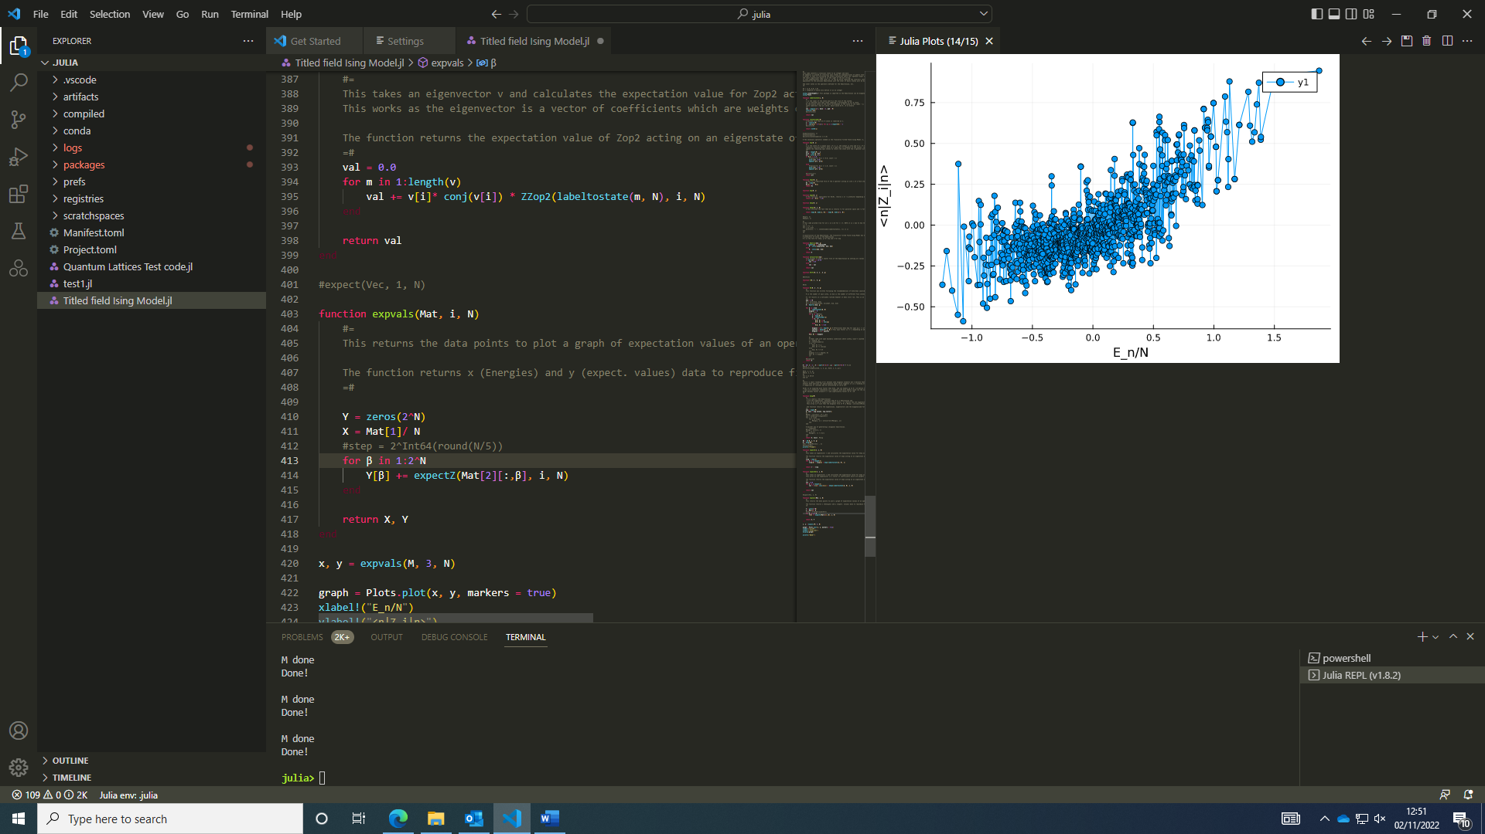After our first meeting, I went back and removed some matrix multiplication which was unnecessary and added markers to the graph to see the points corresponding to energy eigenvalues and their expectation values. This shows a density of points effectively similar to what was produced in Figure 4.2b in the Quantum Nonequilibrium Dynamics paper.

I looked at open (above left) vs periodic (right) boundary conditions and it’s clear that periodic boundary conditions do suppress the fluctuations of finite size systems using N = 10.

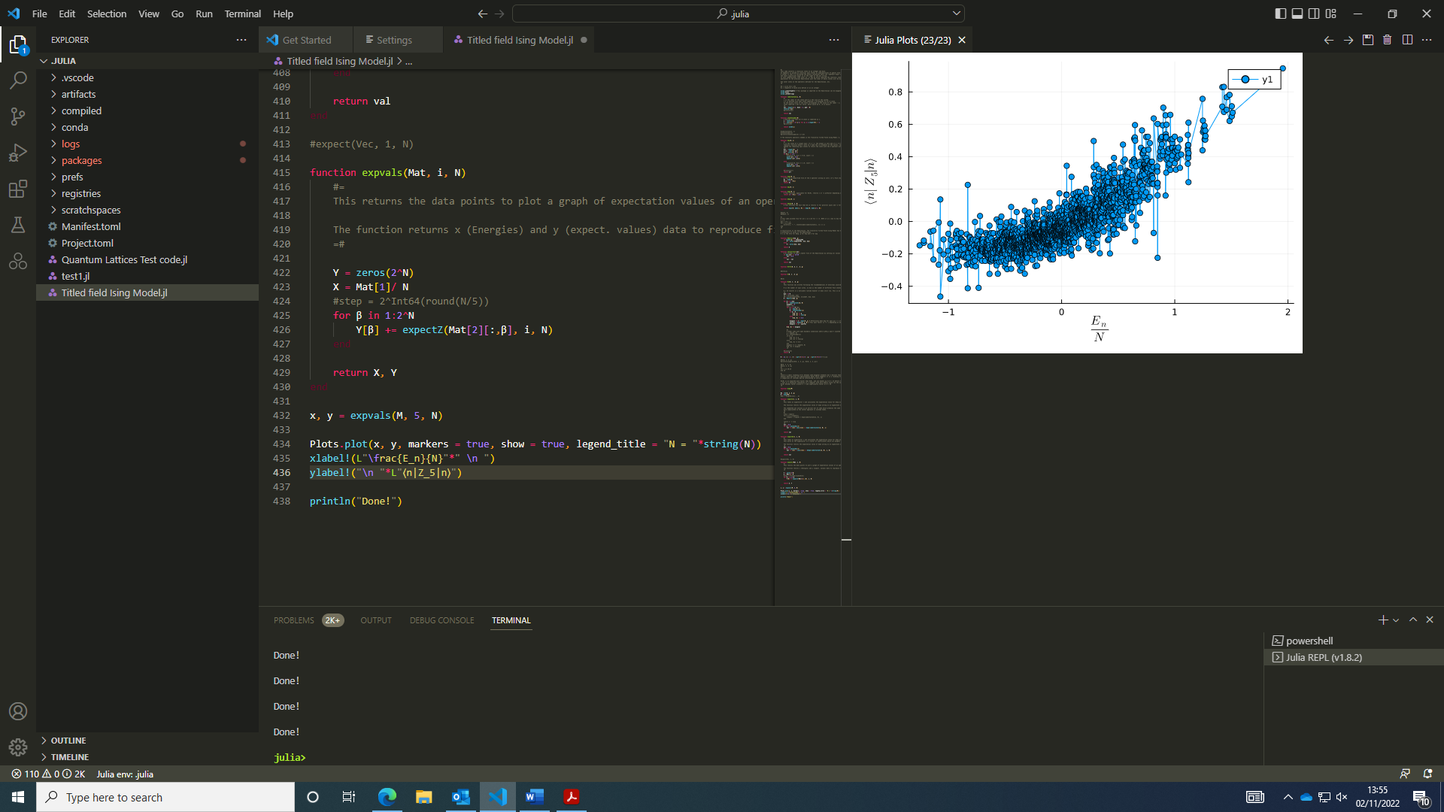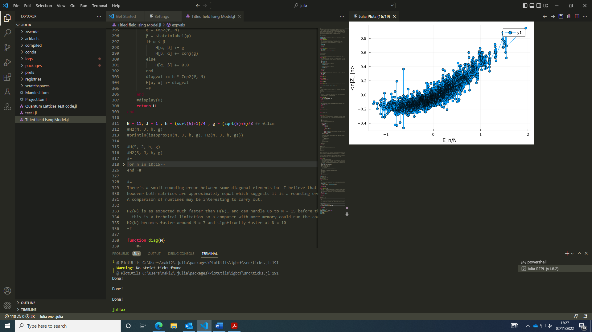For N = 12, with periodic boundary conditions, this resembled the results in the paper given we looked over a larger range of E_n/N given in their results. There’re small differences between outliers in finite size systems for different sites acted on by Z operator. Right had i = 3 but i = 5 looks slightly different but the behaviour is largely the same.

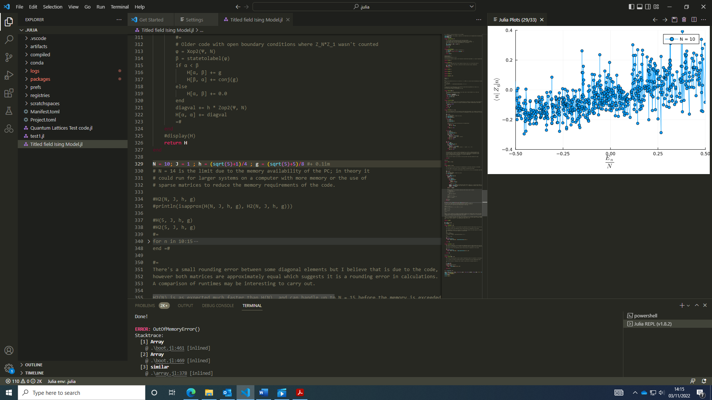

### 03/11/2022:

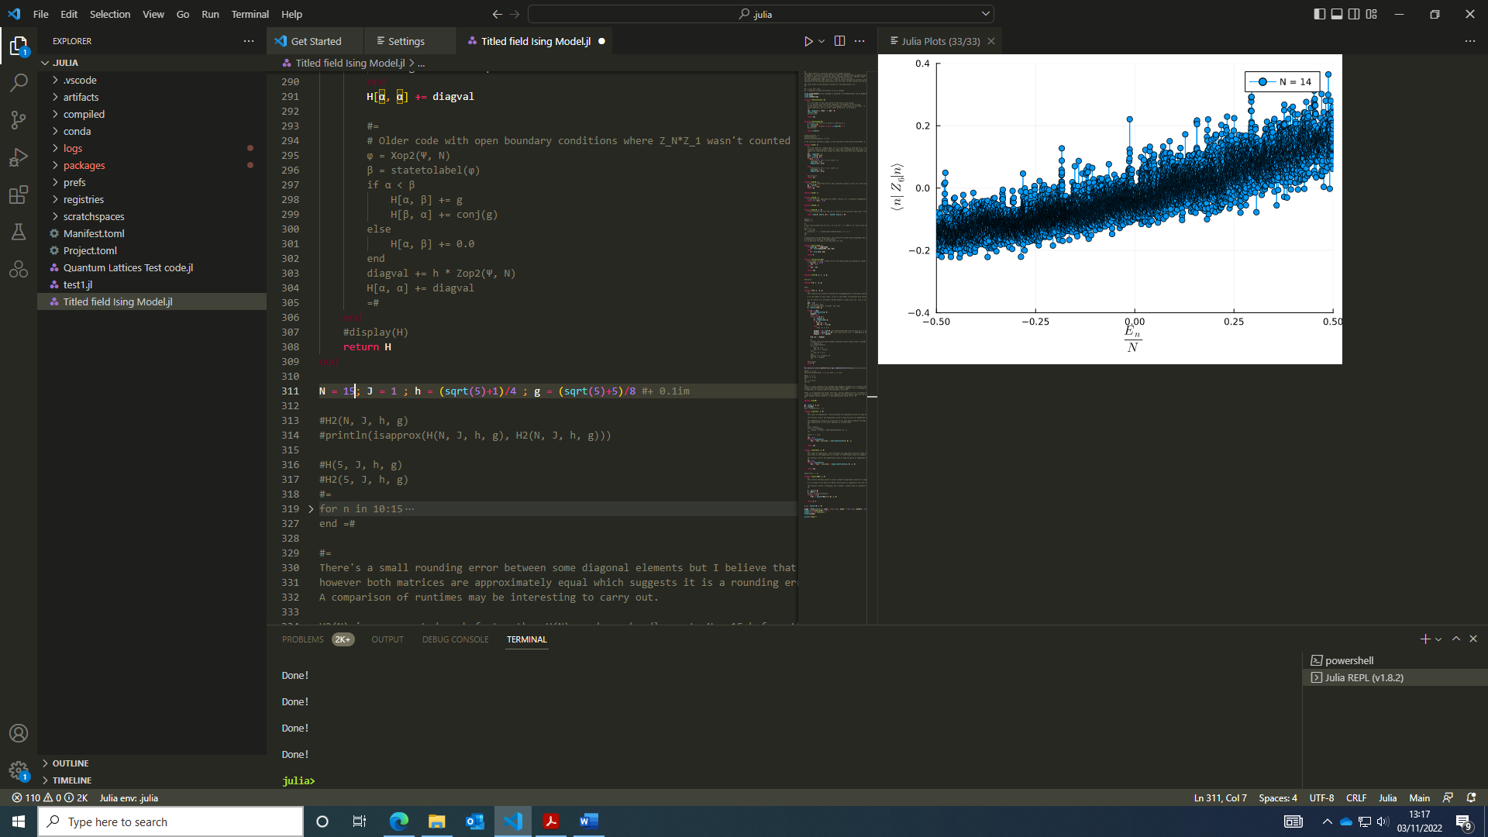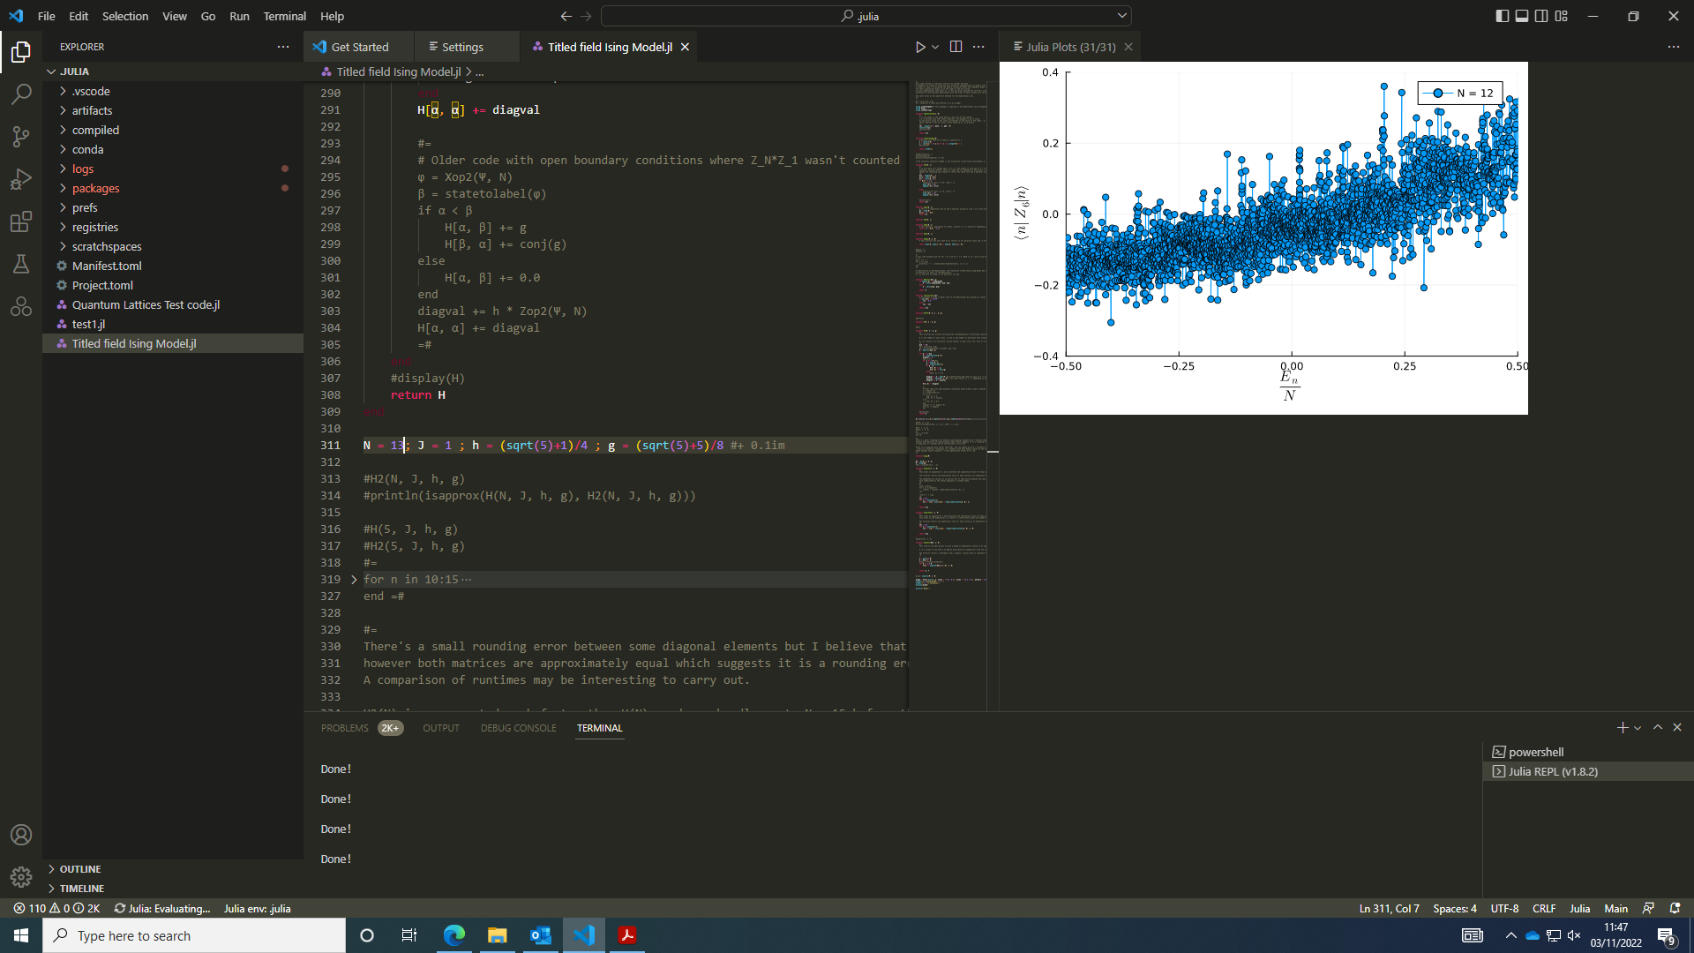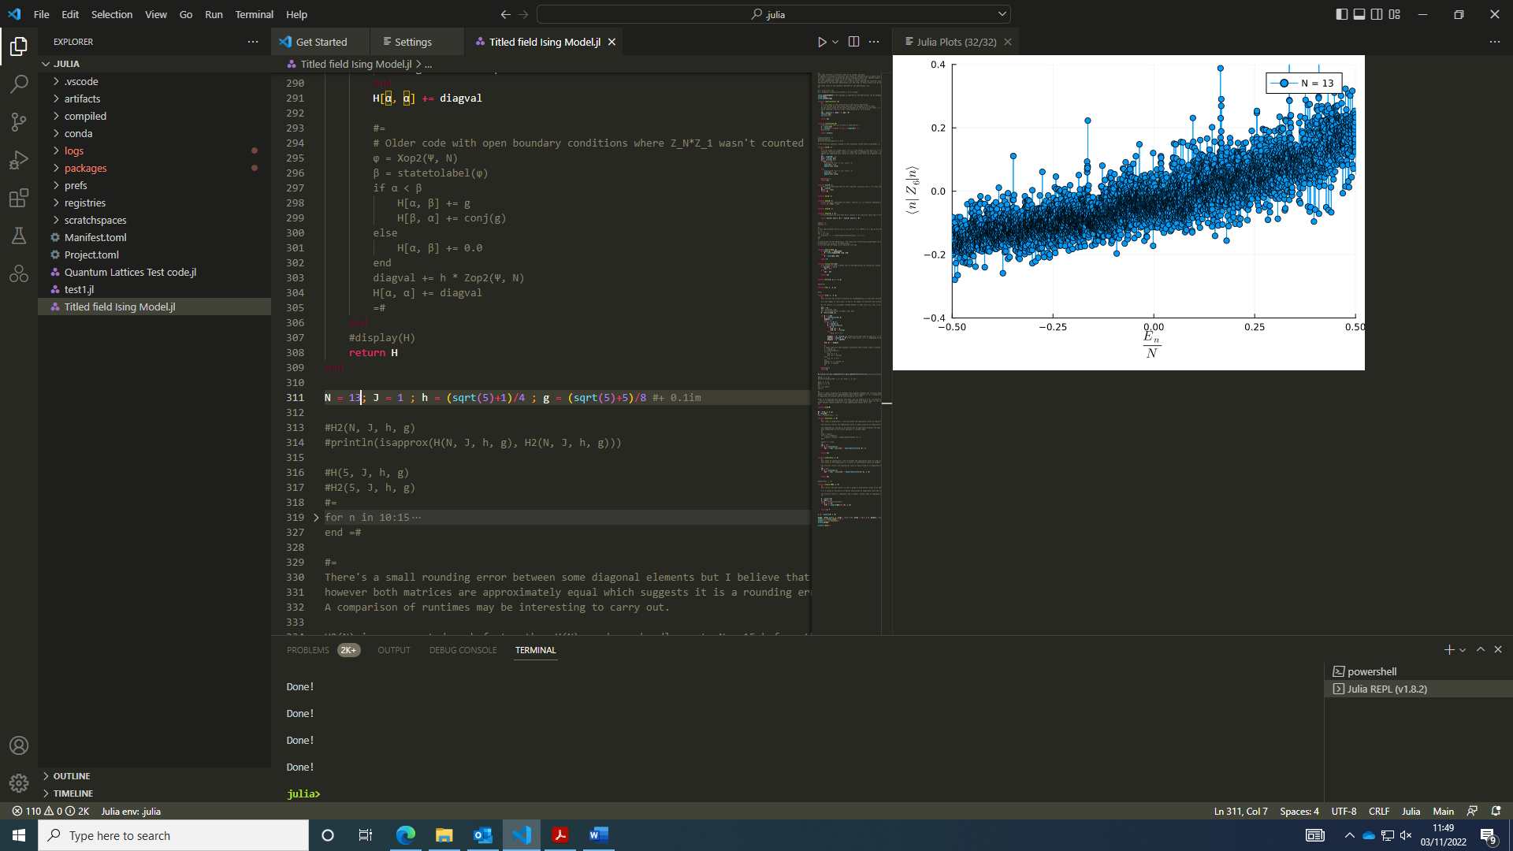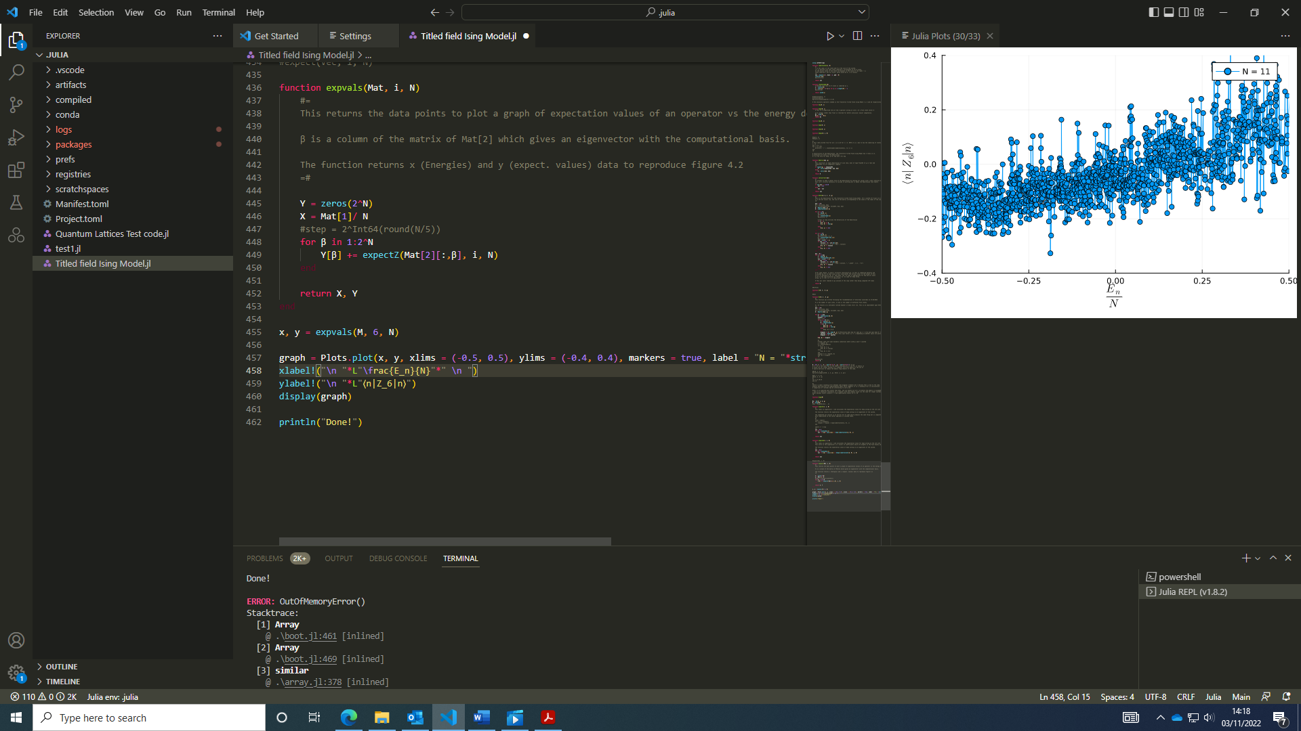I adjusted the plotting window and found these graphs for N = 10 - 14 which compared to the graph presented in the paper look very similar (see coloured line plot).

The plots aren’t identical but show similar behaviour; I think minor differences can be attributed to rounding errors in the code. A gradually increasing expectation value with E_n/N with a negative expectation value at zero energy is clearly seen in all plots with higher N plots reducing the uncertainty in the expectation value at a given energy (line plots are being “squeezed” as N gets larger, as you’d expect in the thermodynamic limit).

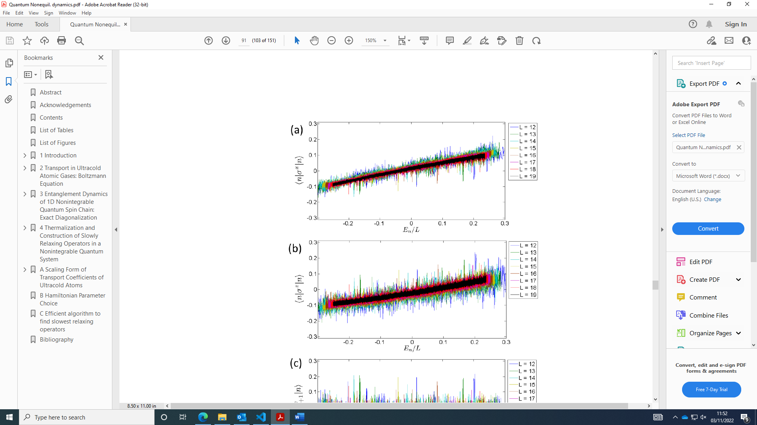NOTE: N and L mean the same thing.

My code is limited at N =14; I could push it further by making some changes using sparse tensors to get around writing the whole Hamiltonian with many zeros in it.

### 04/11/2022:

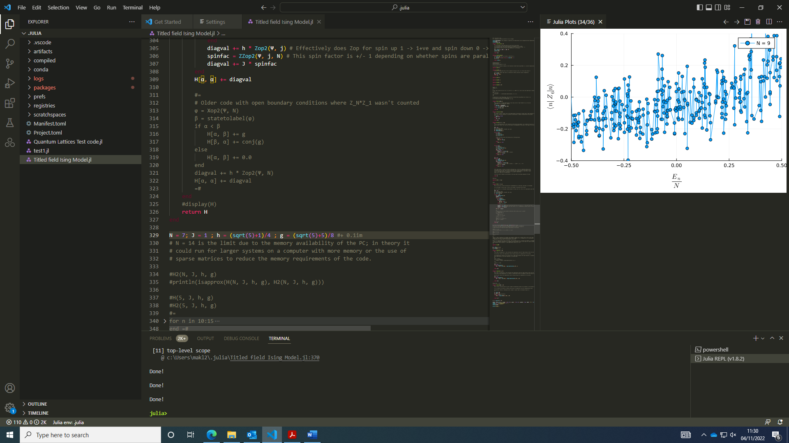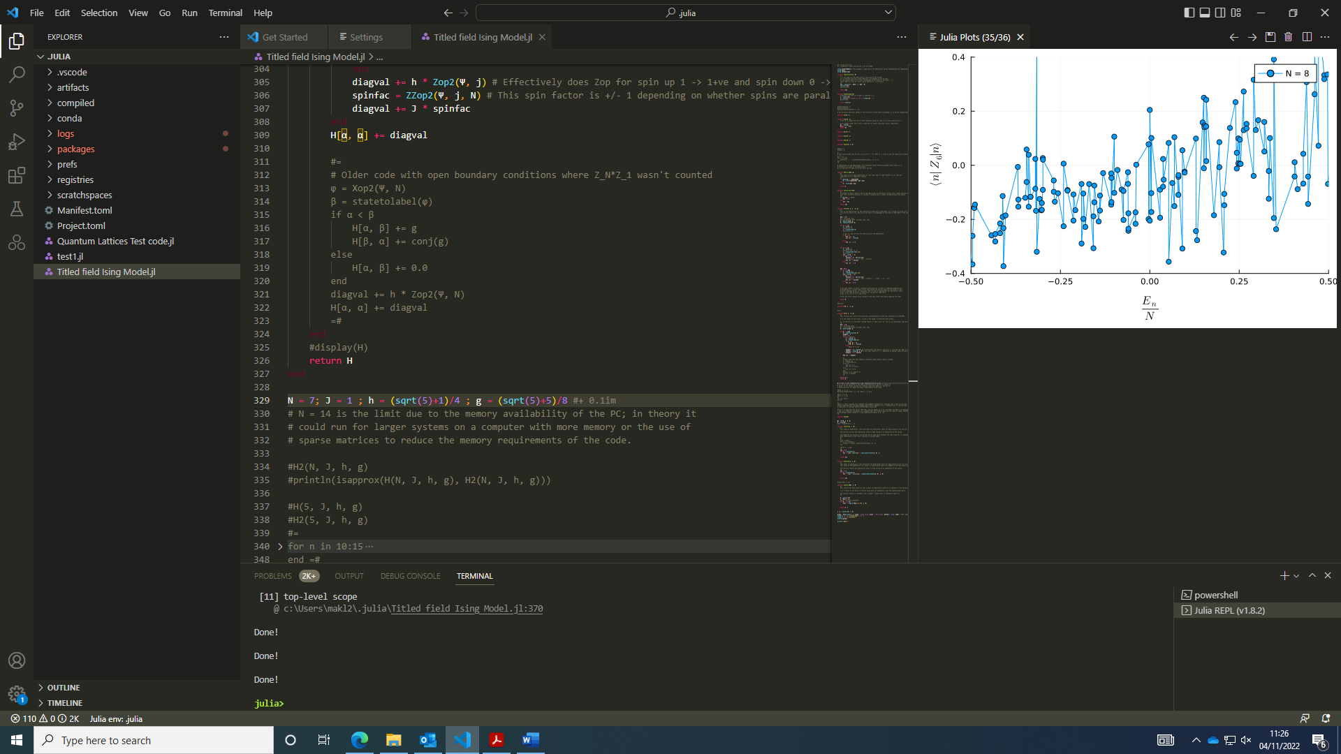I did the same plots above for smaller systems and found larger fluctuations.

However, it would be helpful to have a separate plot to quantify these fluctuations with respect to system size. It could be quantified by an average of differences in expectation values within a given energy window – e.g. max() – min() of an array of values within a given energy window for each system size. Then, multiple energy windows could be averaged over to obtain a more accurate result. I may look at 20 or 30 points around a given energy window although with this approach it’s probably worth scaling the energy window with the system size as larger systems have a higher density of states.

I was half right with this approach: using small energy windows is a good idea however max – min will overestimate the fluctuations by picking anomalous points. It will be better to calculate the variance for each energy window and add up the variances to get a more representative measure of the fluctuations.

### Text Description automatically generatedA screenshot of a computer Description automatically generated with medium confidence07/11/2022:

I looked into the Statistics module in Julia, which can compute the variance for a set of points. Using a module to do this is probably more efficient than any code I could write.

With a function to compute a local variance and sum over these variances, I plotted the variance for the whole energy spectrum and found the variance shrinks exponentially in fact as N increases:

This effect may be due to inappriopriate scaling factor in the code of 2^step / 2^N rather than the correct 1/ 2^step to get the correct form for the total variance. With this correction, I found something linear.

**With a measure of the fluctuations with respect to system size, we see that the variance decreases with system size, which is a signature of ETH. Therefore, if the system behaves according to ETH, we’ll know the long time average settles to a steady value.**

With this quantification of the fluctuations shrinking in system size, I’m moving onto the time evolution of a state (and therefore a step towards finding the long time average of a quantity).

### 08/11/2022:

For an initial state, we take the exponent of the Hamiltonian with time and evolve the state for a time t. In practice, taking the exponent of a matrix in coding form might require a bit of thought.

This forum discussion helped to clarify a few points ([Exponential matrix calculation with the exp() function vs procedure with the use of the eigen() function - New to Julia - Julia Programming Language (julialang.org)](https://discourse.julialang.org/t/exponential-matrix-calculation-with-the-exp-function-vs-procedure-with-the-use-of-the-eigen-function/48798/4)), as did [Matrix Exponentiation | Brilliant Math & Science Wiki](https://brilliant.org/wiki/matrix-exponentiation/). I started writing the time evolution of the Hamiltonian although I’m unsure what time steps to use and whether applying multiple unitary operators for smaller time steps might be more appropriate,

With an idea of matrix exponentiation, I decided to look at importing files into a Julia document so my functions can be defined in their own functions – see <https://www.matecdev.com/posts/julia-functions.html#storing-and-calling-functions-in-a-separate-file>.

I wrote functions into individual files so I could use the include() function to call them in other functions and file scripts.

### 09/11/2022:

Upon first inspection, I think you can use any time step in the evolution; using smaller time steps doesn’t change the state as the product of unitary operators is the same as the unitary operator for a longer time t since the Hamiltonian commutes with itself.

I thoguht about how to represent different initial states. For a simple Fock state, for example |00100>, the state can be generated by labeltostate with the arguments 2^I + 1 with i being the site you want to flip to an up state.

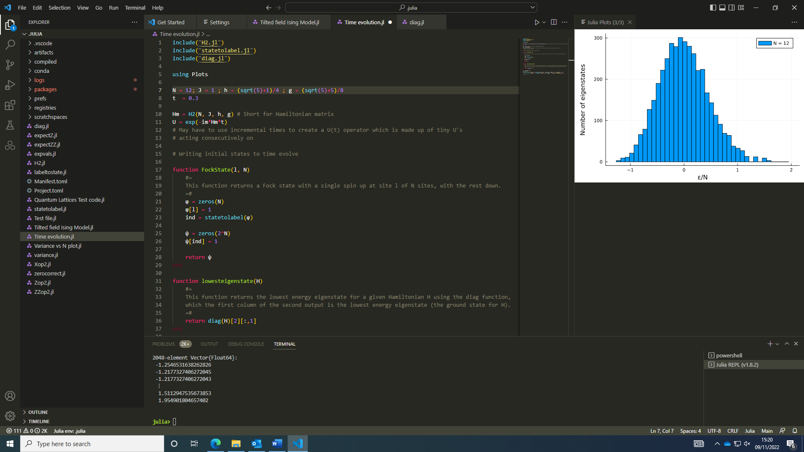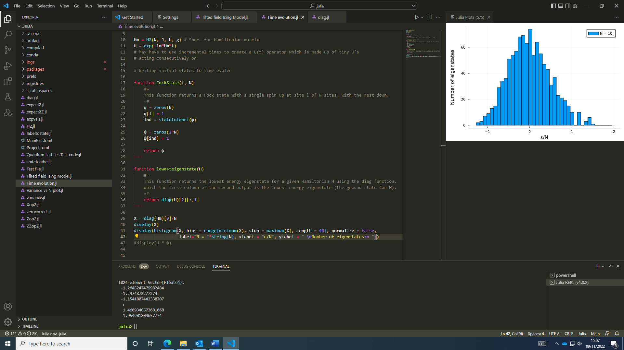The lowest energy state of a Hamiltonian can be obtained from the first column of the matrix of eigenvectors from the function eigen(). This gives coefficients which correspond to states in the computational basis (which are many-body states).

I made a histogram plot of the density of eigenstates for eigenenergies for the tilted field Ising model Hamiltonian scaled by the system size. I did this for N = 10, 12 sites and found as N increases it tends more towards a Gaussian distribution.

To create an initial state with eigenstates in a certain energy window, it would be handy to have a function which can identity an eigenvalue closest to a given value and return its position in the vector of eigenenergies to get the corresponding eigenvector.

I wrote some functions to set up the initial states. With these, I’ll look at operating on the states and calculating time-dependent expectation values tomorrow. This could be done by looping through each individual computational state and determining how the operator acts on each computational basis state.

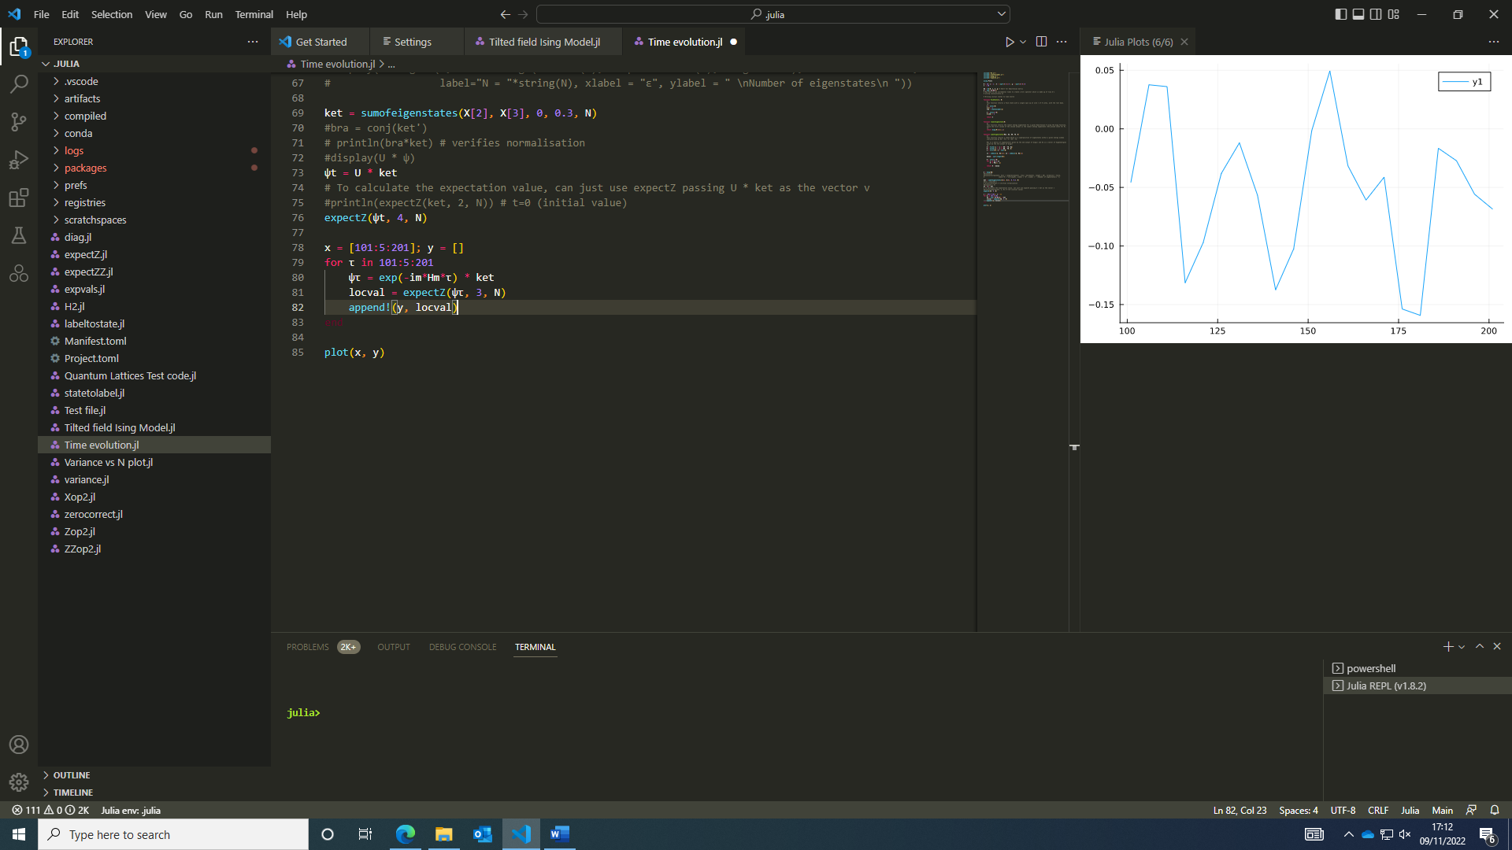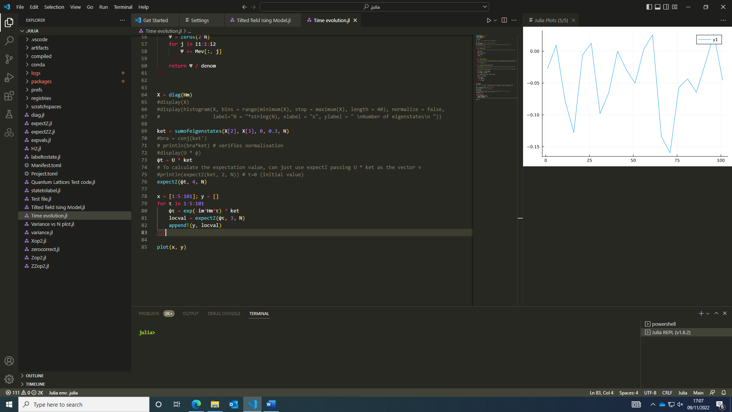I had a quick look at the long time expectation value for a state comprised of eigenstates within a finite energy window and got this plot. As expected, the finite size of the system (N = 10 in this instance) shows some unpredictable oscillations. N.B. Plotted for time vs expectation value of Z operator on site 3 for t = 1:5:201.

### 10/11/2022:

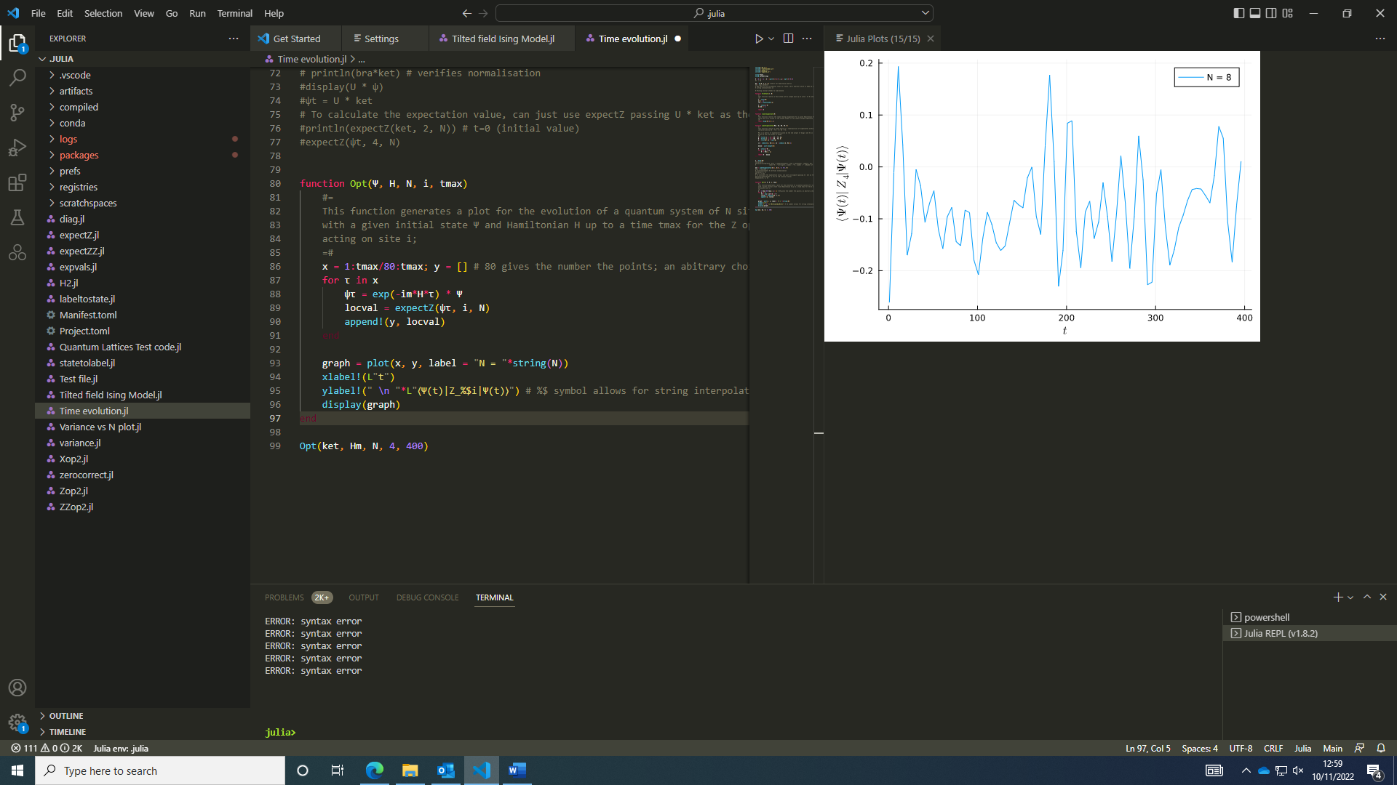I started today by writing a function for the time evolution of a state’s expectation value, specfically the Z operator acting on a site (the 4th one in both graphs). One such graph produced can be seen on the right here.

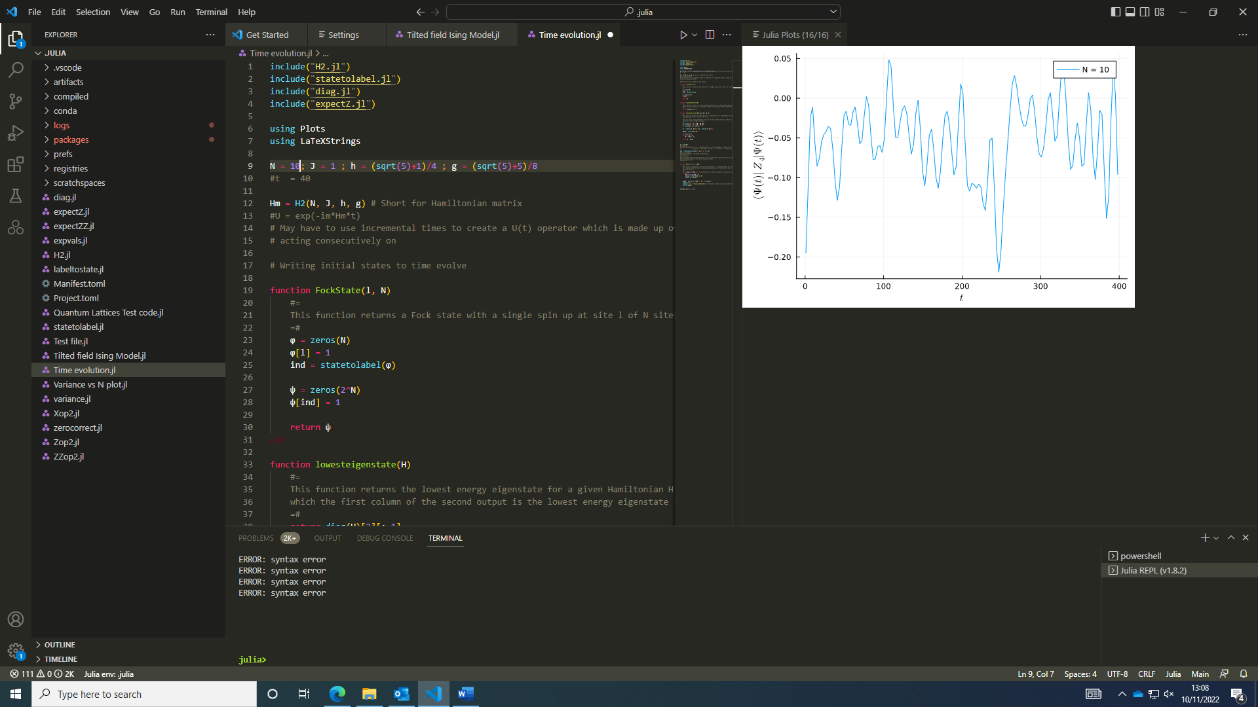I found around N = 10, the code runs slower which I think can be attributed to the exponentiation of a 2^10 x 2^10 matrix. At this point, it may be worth making use of the sparse matrix features of julia. It did after some time produce a graph (see below).

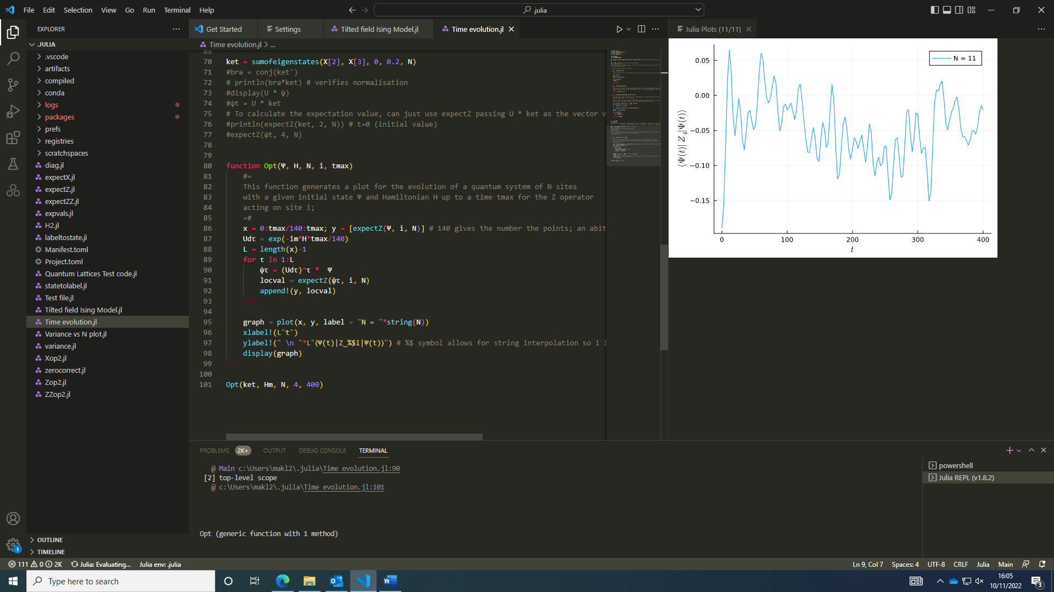I wrote a function for calculating the expectation value of X, which is a little bit more involved than the Z expectation values since X acting on a computational basis state changes the state (rather than changing it be a phase). However, at no point is the matrix for the operator constructed, since for larger system sizes this form of an operator will prove more useful than a 2^N x 2^N matrix multiplied with 2^N column and row vectors of the time evolved state.

For the change to sparse arrays, we form the Hamiltonian in terms of a Sparse Array and exponentiate it in a similar way using expmv() (see documentation at [GitHub - marcusps/ExpmV.jl: Julia package to compute the result of expm(t*A)*v when A is a sparse matrix, without computing expm(t*A).](https://github.com/marcusps/ExpmV.jl)) in place of exp(). This will help to give the time evolved wavefunction of a sparse matrix. NOTE: The Hamiltonian is sparse as there’re only N+1 entries on each row and 2^N – (N+1) elements are zero on each row so obviously for larger N the Hamiltonian becomes sparser.

I created a sparse array for the Hamiltonian however have hit a problem with the eigen() function in Linear Algebra not being able to handle a Sparse Matrix; there probably is an easy workaround I will look into tomorrow.

One possible fix is the use of Arpack - [Standard Eigen Decomposition · Arpack.jl (julialinearalgebra.org)](https://arpack.julialinearalgebra.org/stable/eigs/), a generalised package for large-scale eigenvalue problems which seems independent of the matrix type…

### 11/11/2022:

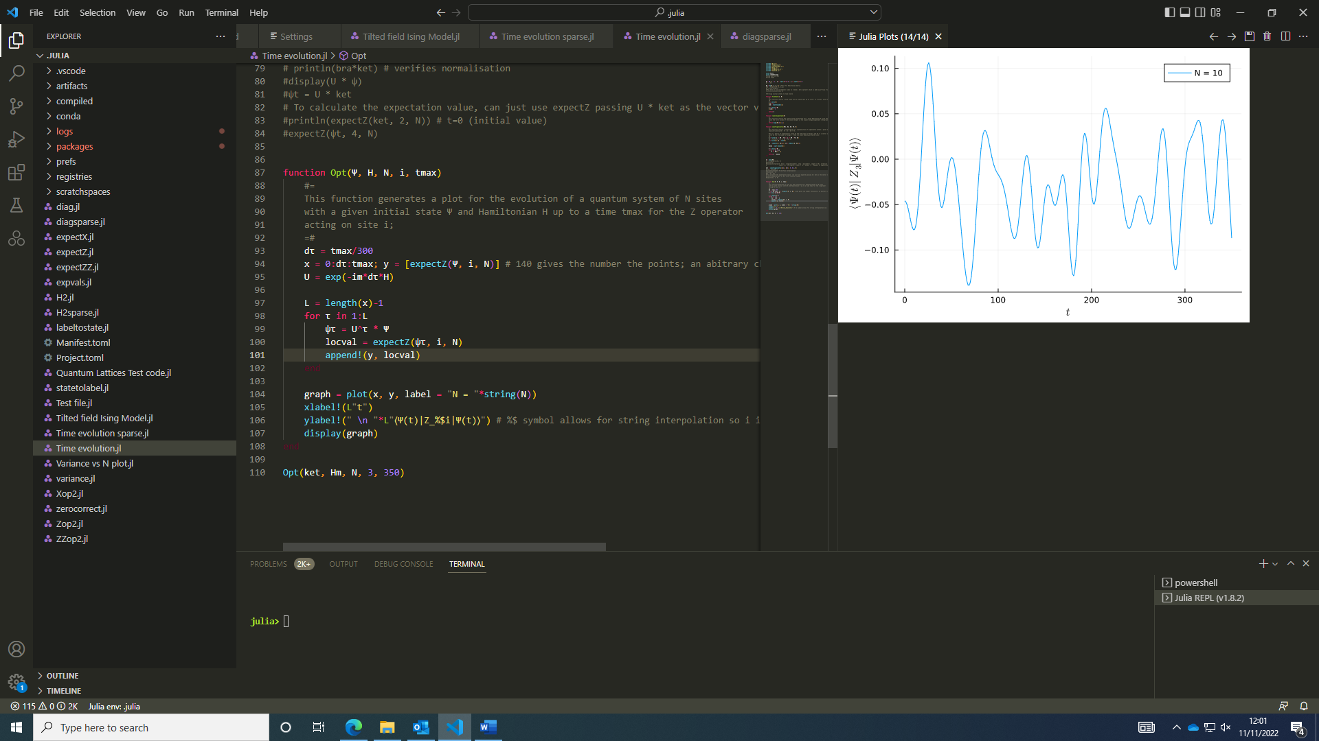Today I started by looking at an unusual error I got in using the Arpack function and trying to find the eigenvalues of a sparse matrix. I may have found a fix but it doesn’t complete running; I think the issue might be in the argument supplied to the which parameter in eigs().

I looked back at the earlier code and defined the unitary operator outside the for loop so it’s only calculated once and raised to a power for each time step. This sped up the code producing a smoother looking graph.

I rewrote the diag and H2 functions for sparse matrices and the functions appear to work properly however there is a discrepancy in the resulting eigenvector matrices which impacts the resulting long-time expectation values as well as the initial starting states. I believe the Hamiltonians are the same so I may try evolving from the same initial state.

If the states are the same, the functions are correctly reproduced (I used the same initial state constructed from H2 and diag but evolved using the dense/ sparse forms of the Hamiltonian matrix) however the construction of a sum over eigenstates using diag and diagsparse produced different results for some reason. Therefore, the issue can be tracked back to how eigen and eigs work to construct the eigenstates of the system (the eigenvalues are the same except eigs leaves out one value). I feel like this is affected by how eigs doesn’t count all the eigenvectors – it has 2^N – 1 eigenvalues and eigenvectors rather than 2^N.

Another pitfall is that eigs doesn’t return the same eigenvectors for the same Hamiltonian in dense or sparse form. This wouldn’t be a problem if a fock state was given which is the same in either case but states relying on eigenstates of a sparse/ dense Hamiltonian matrix may be hard to compare. I plan to think about this over the weekend and discuss it with Achilleas on Monday.

For the |00000100> fock state (L=5), the expectation value looked like this for Sparse and Dense Hamiltonians, showing the code agrees for states not constructed from the Hamiltonians eigenstates (e.g. Fock States).

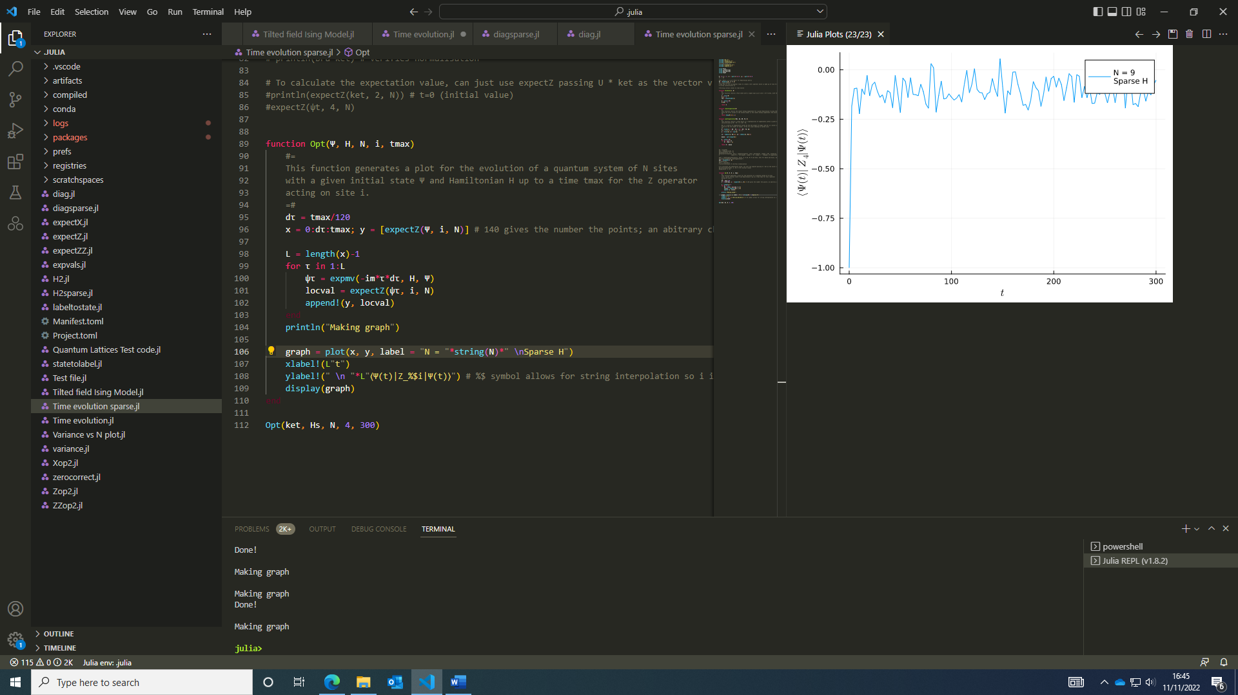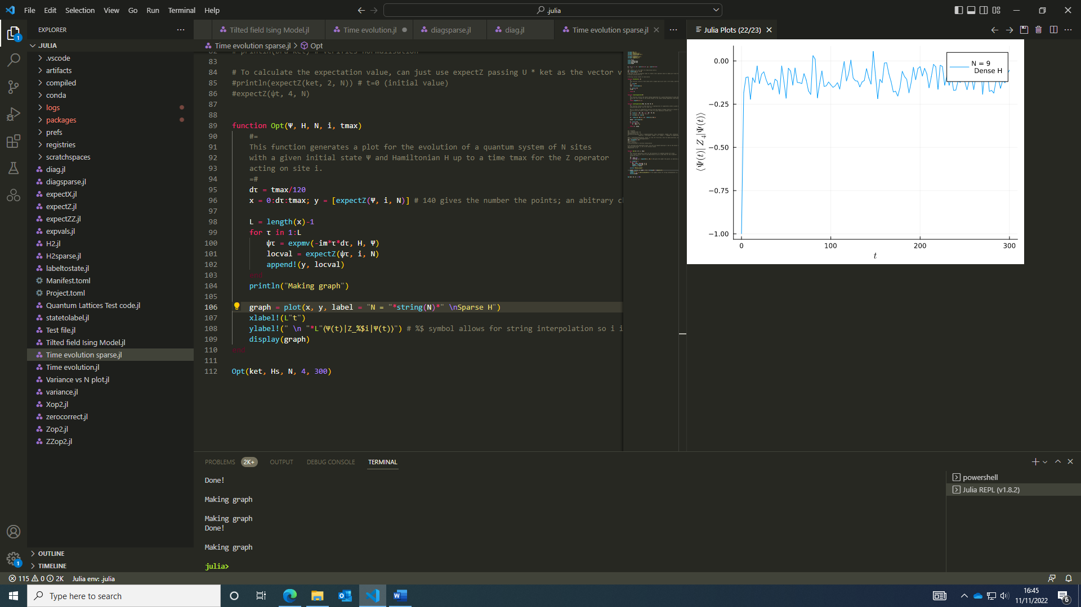

### 14/11/2022:

If I choose to use the eigenstates constructed from the sparse Hamiltonian to create a superposition of eigenstates/ lowest energy eigenstate and evolve with either the dense or sparse Hamiltonian (within similar system sizes), the evolution should appear the same from the same state for the same Hamiltonian.

This justifies that both forms of the Hamiltonian are identical and the difference in eigenstates comes from how the eigenstates are computed in the functions from different packages. Eigen from LinearAlgebra (used on the dense Hamiltonian) and eigs from Arpack (used on the sparse Hamiltonian) compute the eigenvectors differently but return the same eigenvalues although eigs doesn’t return all the eigenvalues (it always seems to omit one at the highest energy however this is acceptable when we want the lowest energy eigenstate or a range of energy states around the middle of the eigenenergy spectrum).

With these differences in mind, I chose a superposition of eigenvectors from the sparse form of H and evolved it in time with the dense and sparse forms of the Hamiltonian and found they were the same.

Using the same state constructed from the dense Hamiltonian around E = 0 +/- 0.2. Sparse/ dense H in the label denote the Hamiltonian used in the unitary evolution operator.

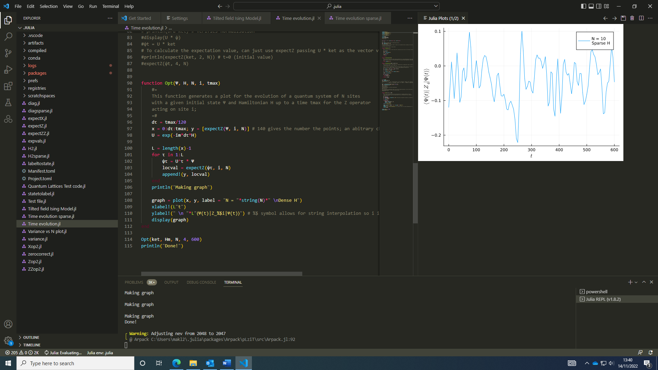 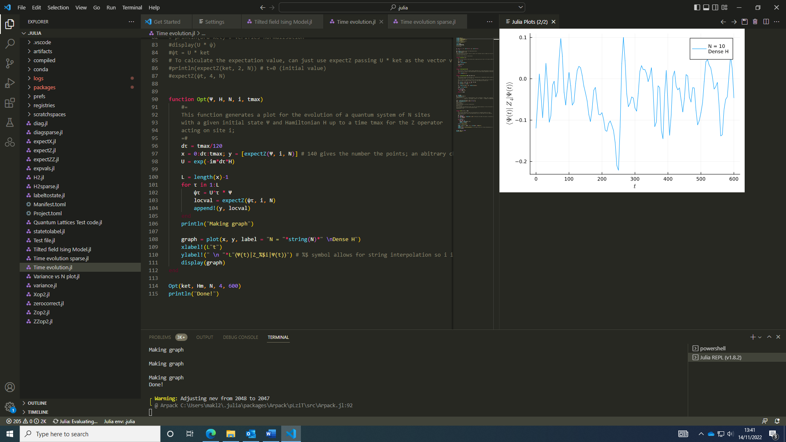

Using the same state constructed from the sparse Hamiltonian around E = 0 +/- 0.2

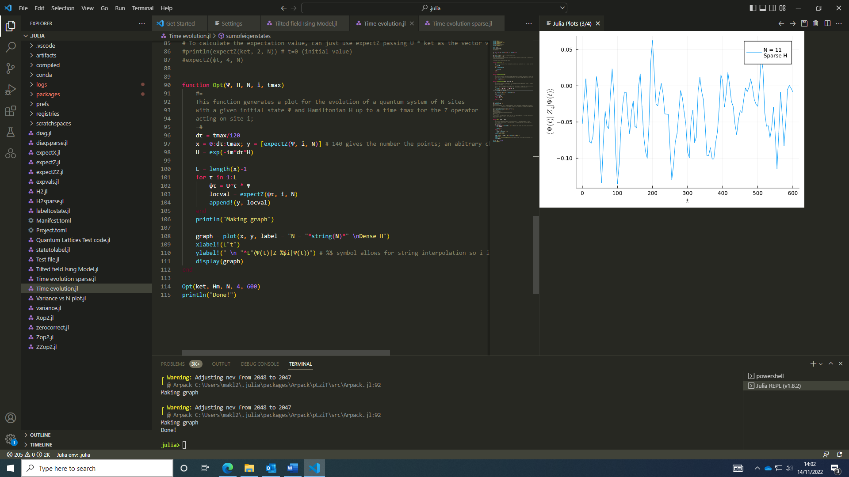 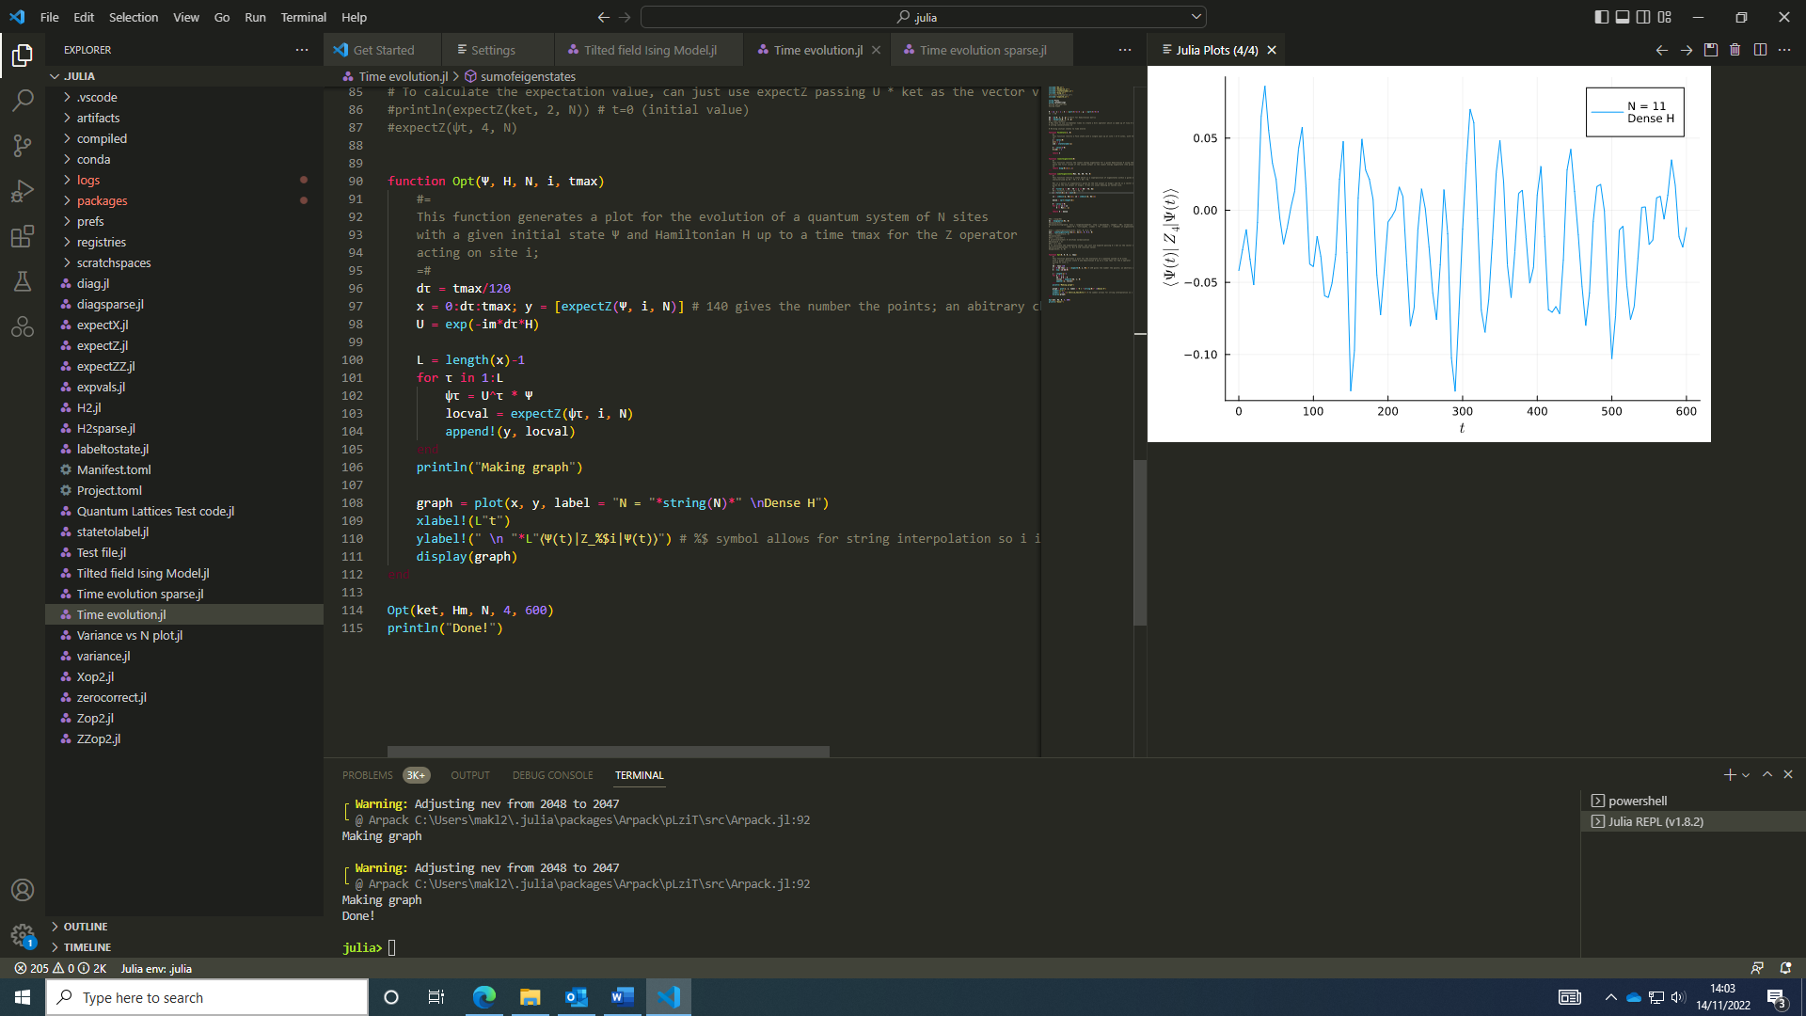

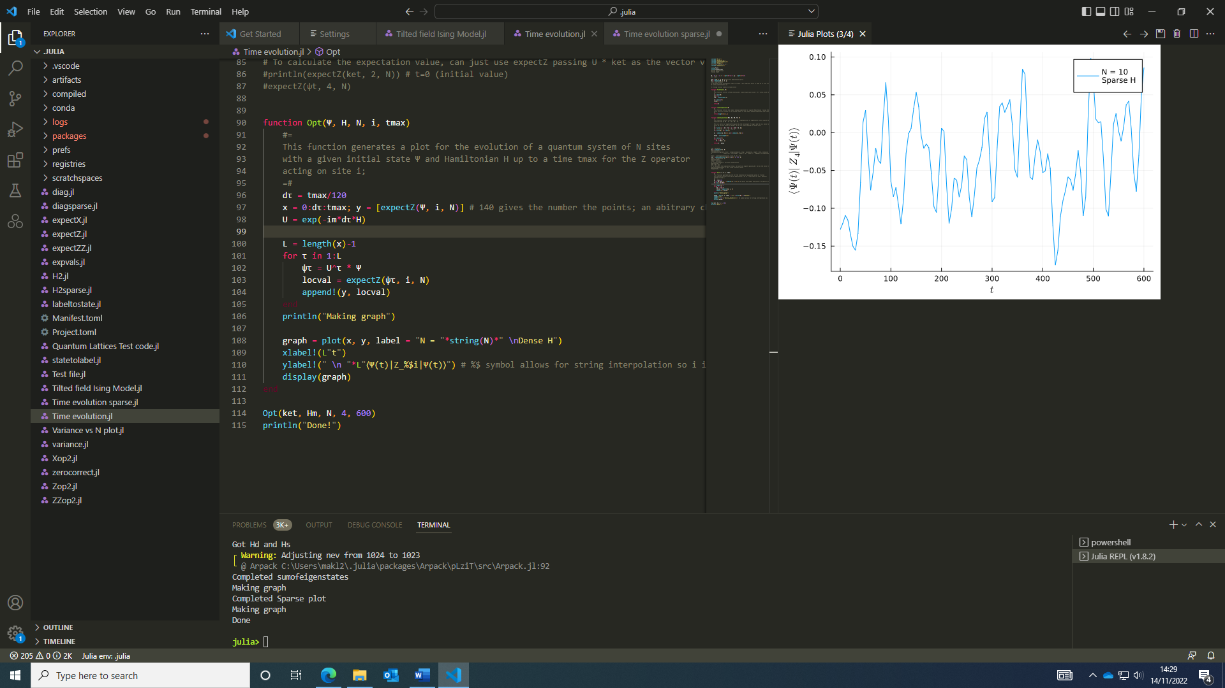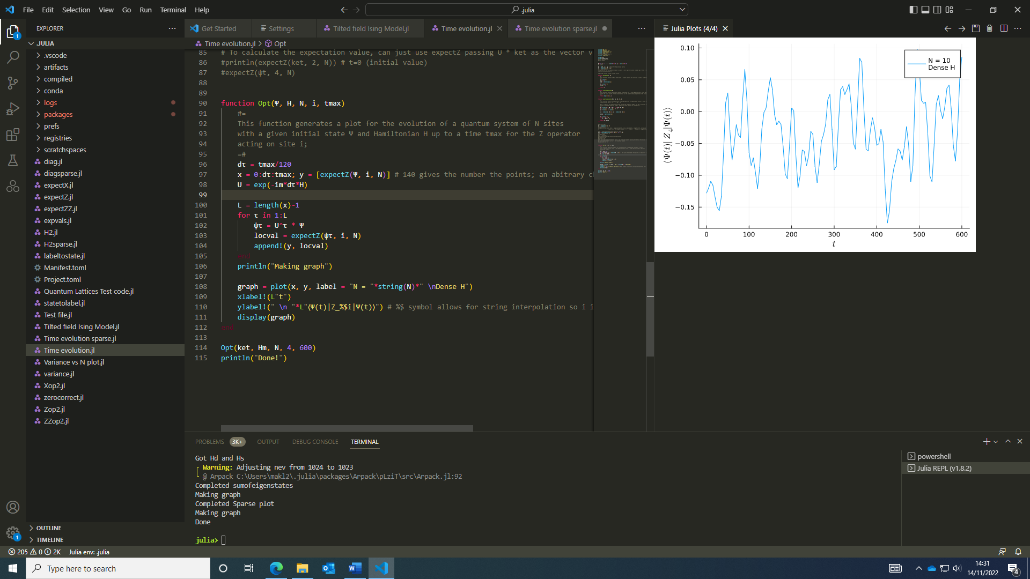These 2 graphs, using the “same” eigenstates constructed from the sparse Hamiltonian. These aren’t in fact the same state, as the graphs were produced in separate files and eigs doesn’t reproduce the same eigenvectors each time. Using the same state in the same file, with the same sparse and dense Hamitlonians, the results were reproduced:

With the sparse Hamiltonian function verified as working and reproducing the results of the dense Hamiltonian function, I decided to increase the system size and see the effects of system size on equilibration. Despite using a sparse form of the Hamiltonian, the code was limited by memory in storing the eigenvalues and eigenstates of an N = 16 system (N =15 was the maximum). I think I can get to larger system sizes by truncating the eigenvector matrix to only store the eigenvector(s) I need, such as the lowest energy eigenstate or the superposition of eigenstates in a given energy window however I’m unsure if it’s possible to only compute a subset of eigenvectors.

It was possible to reduce the size of the output of eigs, and save memory, by computing the eigenvalues and correspondign eigenvectors around an energy value (given by an argument sigma) and the number of eigenvalues could be given through the number of eigenvalues argument nev however I elected to choose an arbitrary smaller size which excludes small and large values and can then be reduced again in the sumofeigenstates function.

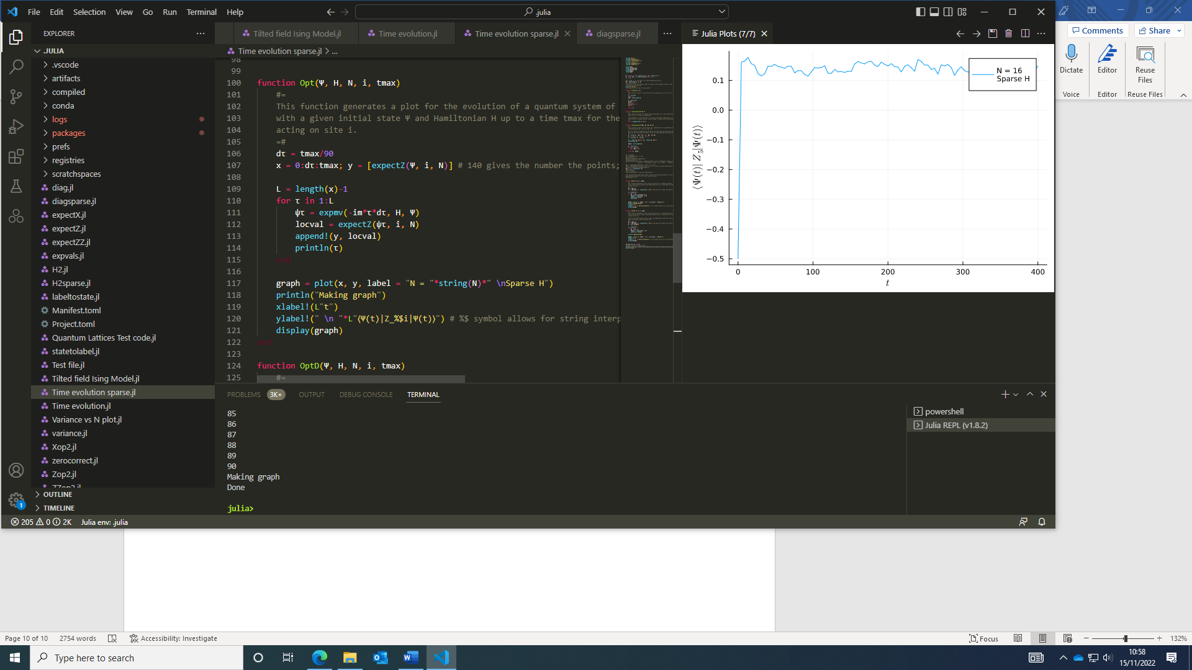It takes a while to run, however it does eventually produce a graph for systems larger than previously possible using the arguments in eigs to reduce the number of eigenstates calculated. This took a long time for N = 16 so I chose to create an arbitrary superposition state of 4 Fock States rather than a sum of eigenstates to see the evolution, which is seen right.

### 15/11/2022:

With more Fock states, the system takes longer to equilibrate which is why there was a sharp equilibration around 0.12 with some fluctuations about this value for only a few Fock states.

The slowest part of the code to run is the imported function eigs, to get the eigenfunctions of a sparse matrix so we can use a superposition of eigenstates as the initial state. I may try constructing a larger superposition state of Fock States of equal weights just to test the code for a state with more computational states.

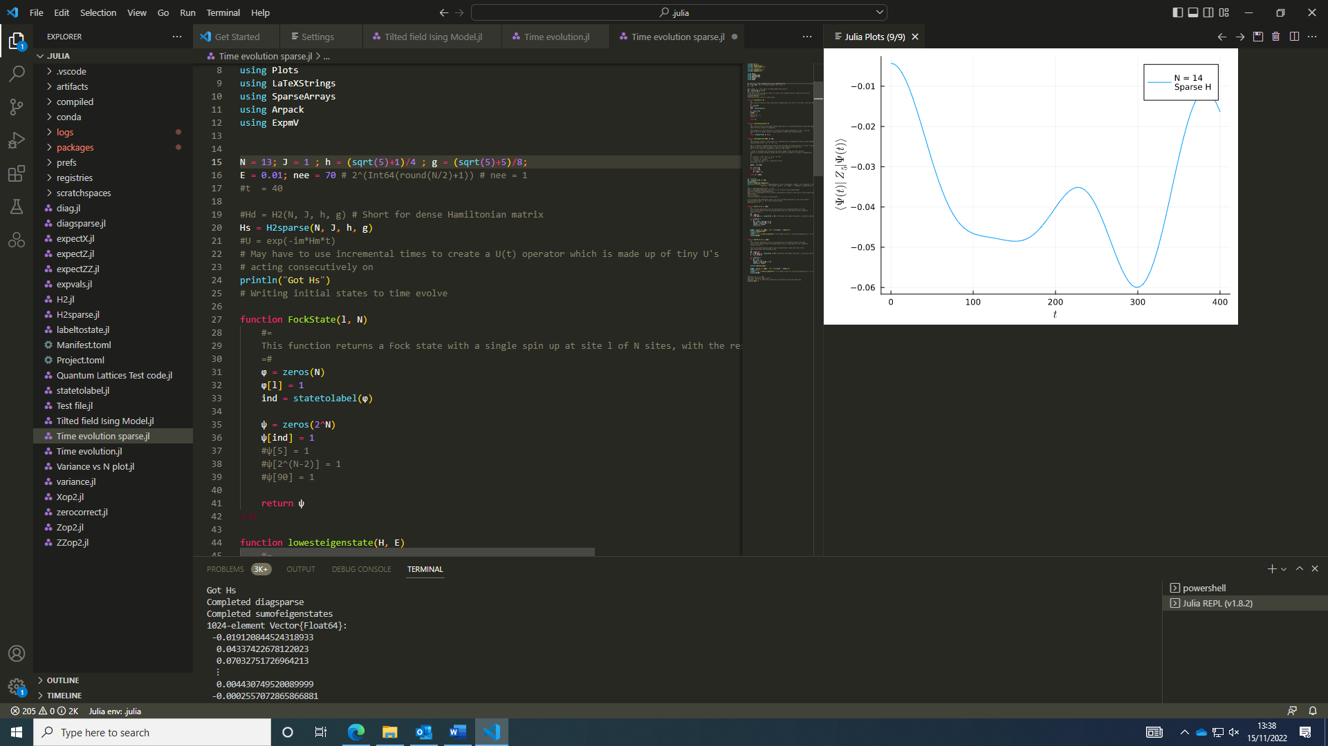I found N = 16 is the limit using eigs() as N = 17 produced an outofmemory error which could be difficult to get around. It would also be useful to have a faster way to get around getting the eigenstates. I constructed an superposition state out of the 70 closest eigenstates to E = 0 and found a smooth function that doesn’t settle to an equilibrium value in the time scale looked at. I chose to define it by eigenstates closest in energy rather than filtering eigenstates to save on memory.

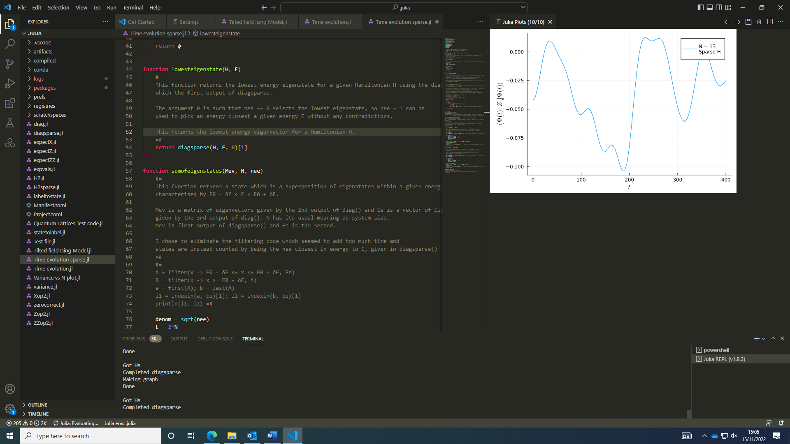The graphs here use the same parameters in the Hamiltonian, with an energy centred around 0.01 and nee = 80 eigenstates were included.

I decided to initialise a random product state and see how the expectation value evolves in time for the state for different system sizes; as the system size is changing, a state is one system wouldn’t be the same in another system without the states of the extra sites being defined e.g. as zero, so a rand(1:2^N, 25) is used to get a random superposition state using these labels.

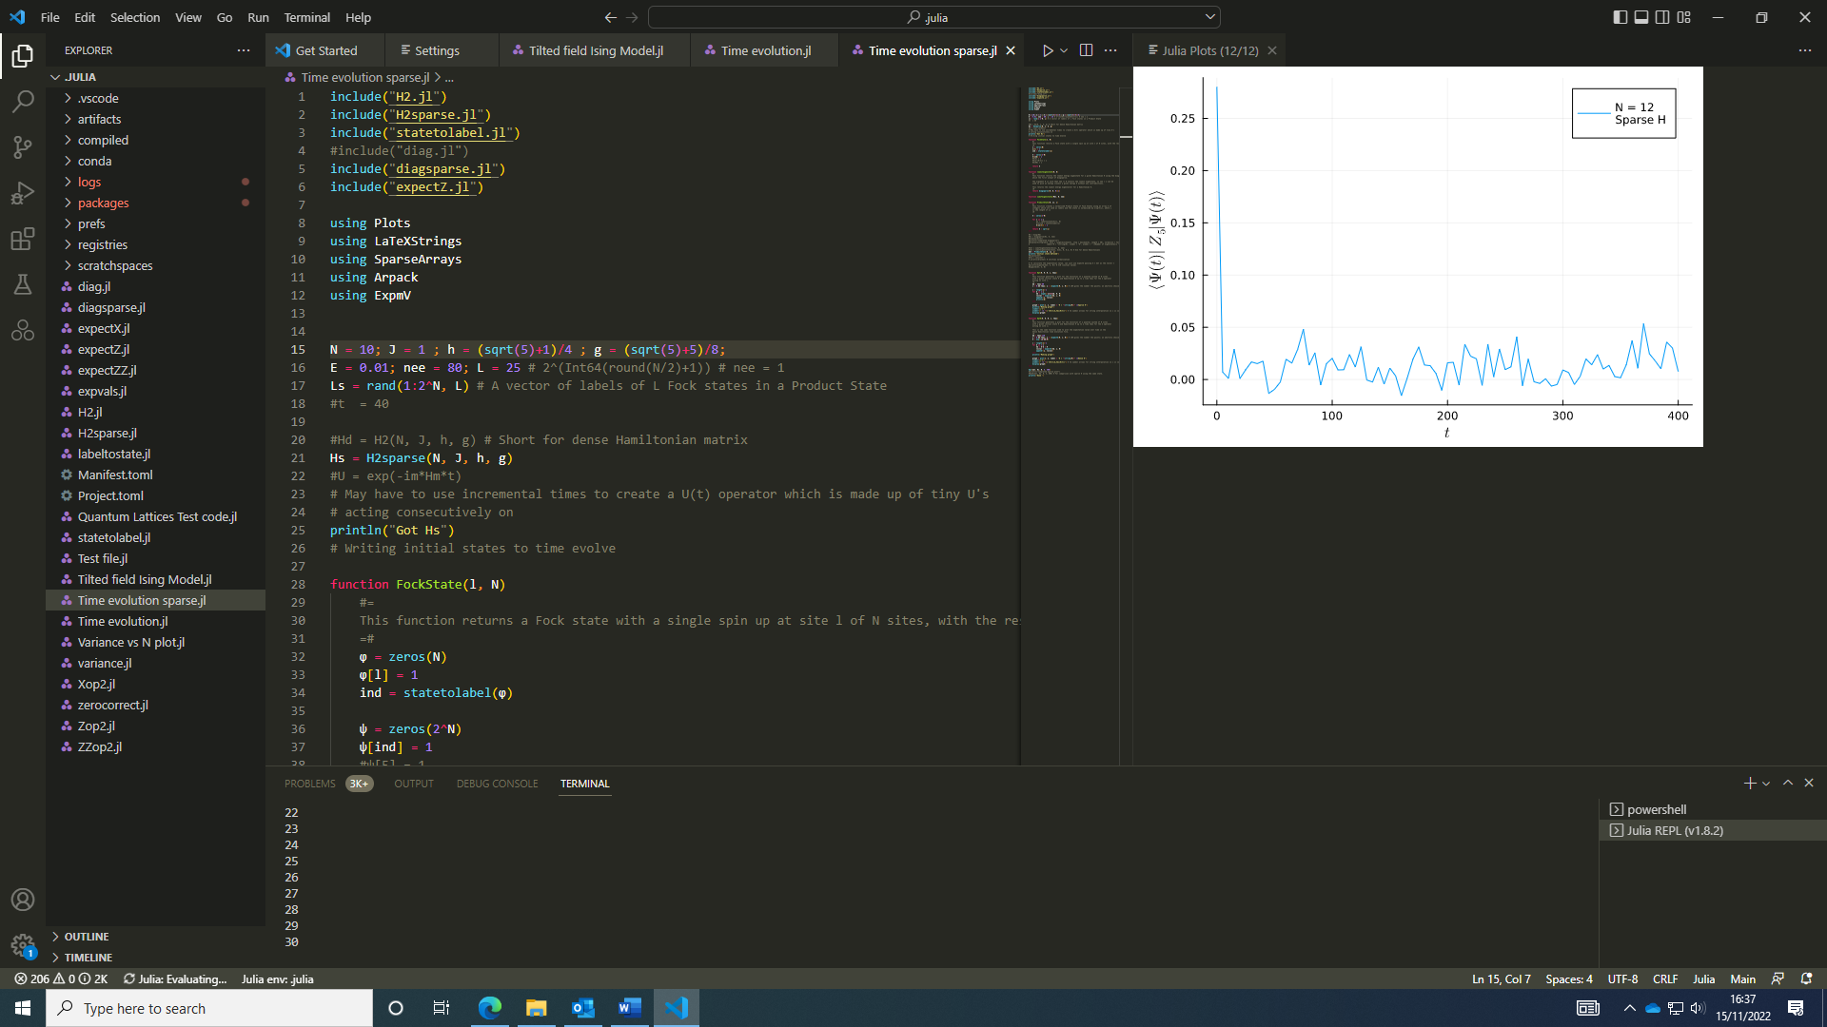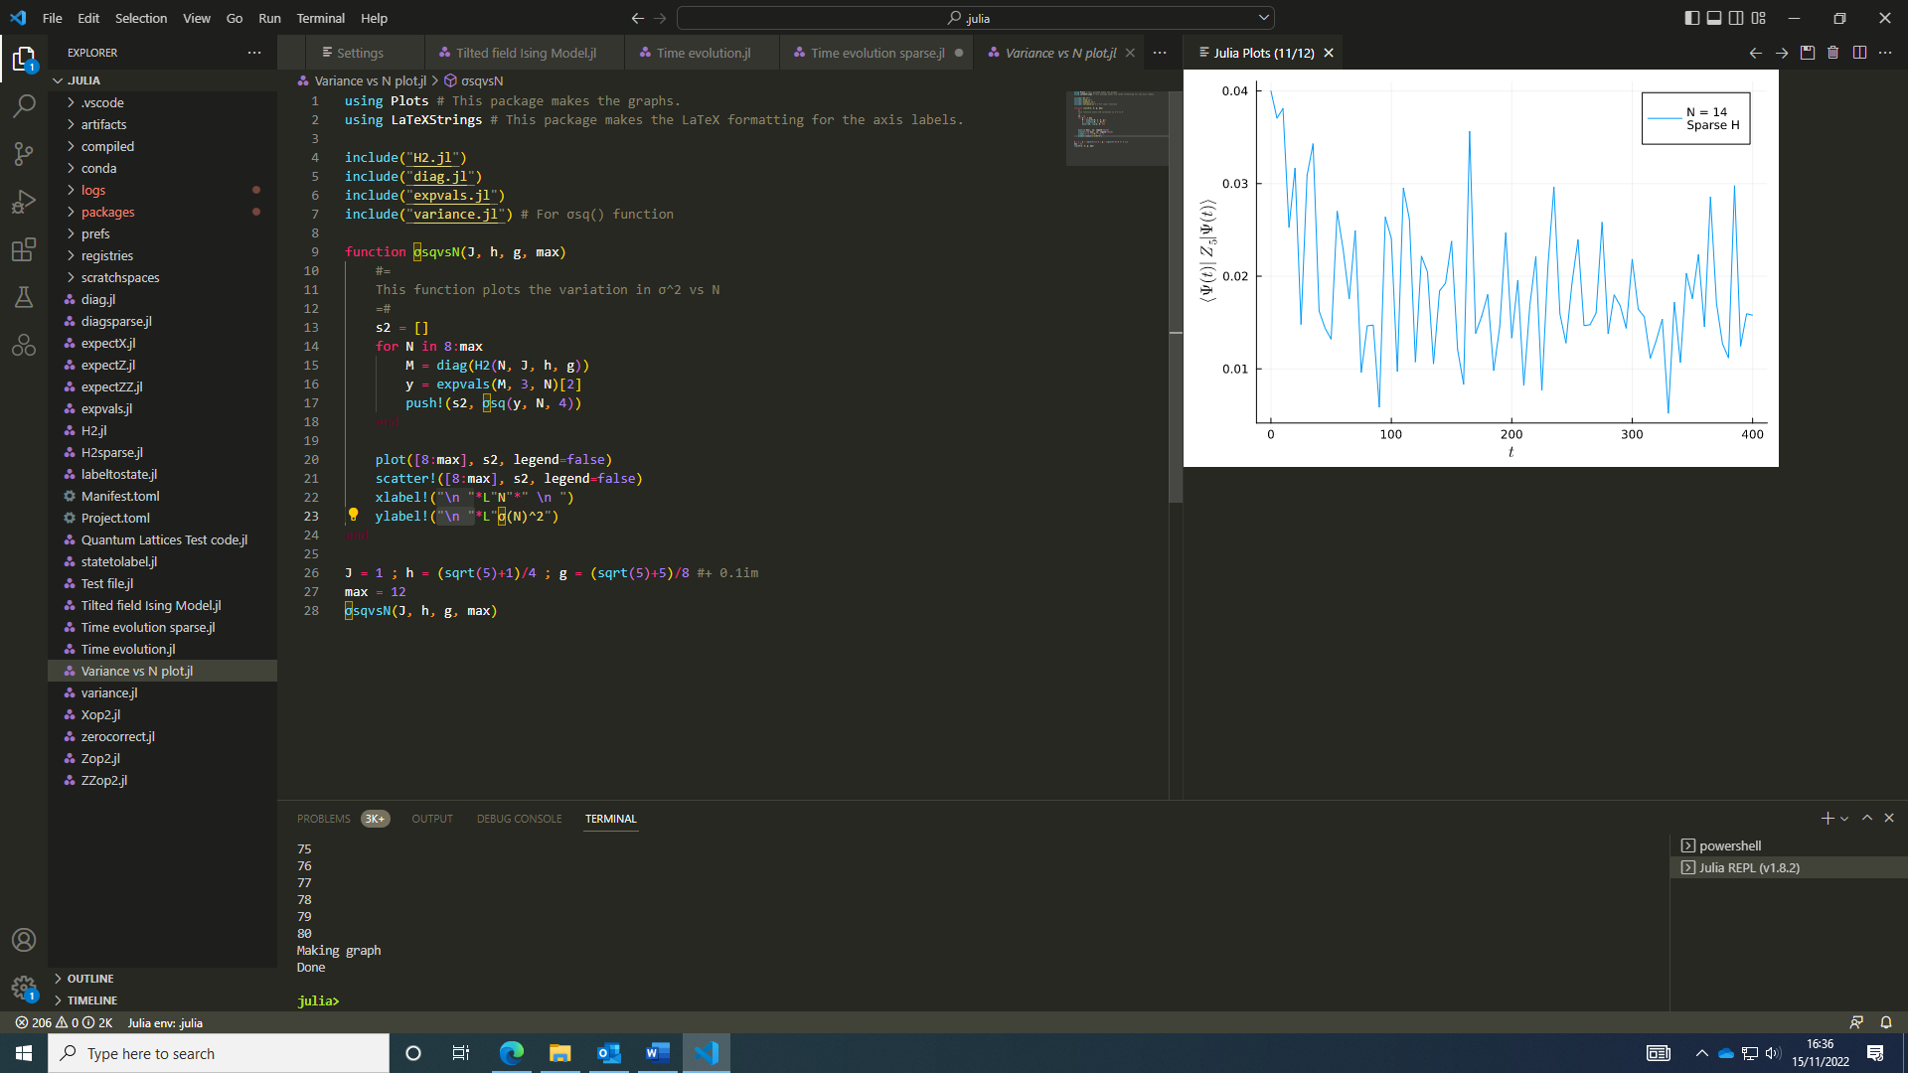These are some plots with product states:

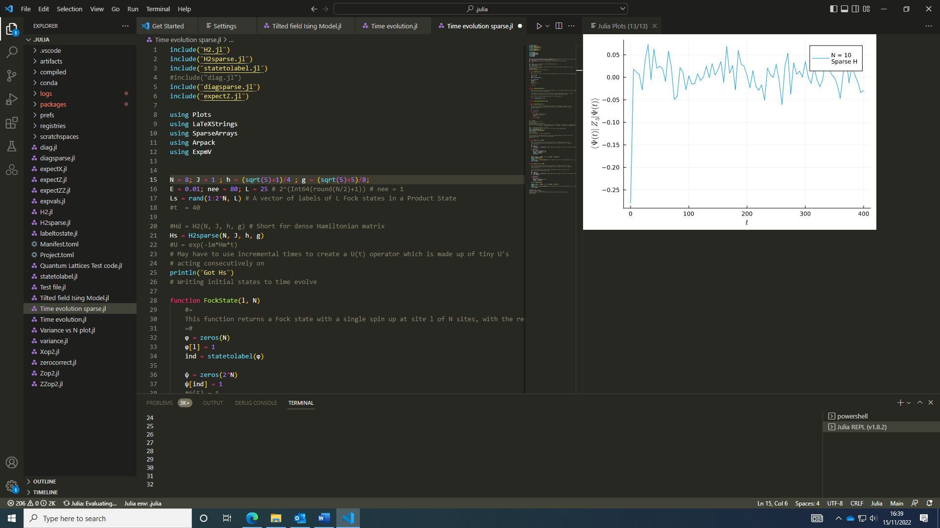 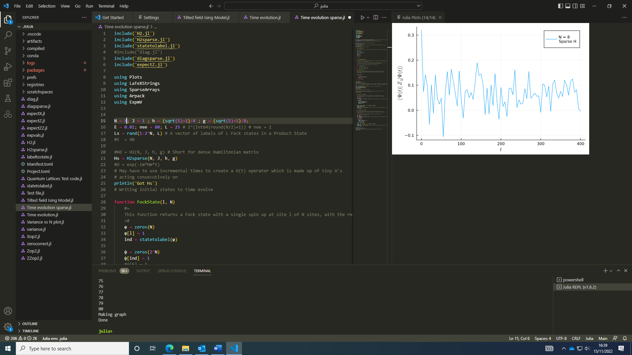

As one expects, the fluctuations do appear to decrease with system size; tomorrow I shall try to calculate the variance of this to quantify this.

### 16/11/2022:

I tried running it for N = 18 however this did take a long time to run (over 2 hours) so only suitable for running code for large systems overnight to get results the next day.

I backed up my code to Github – see <https://github.com/Kieron25/PhD-project-code.git>

I joined today’s seminar hosted on Zoom by Žiga Krajnik about “anomalous fluctuations and dynamical universality”. It was an interesting talk and worth a rewatch to understand more of the content.

I implemented some changes based off Aydin’s recommendations such as using Expokit rather than ExpmV from Arpack, since the former package has a similar function which runs significantly faster so should noticeably reduce the runtime for larger systems as well as a better way of finding the ground state (lowest energy eigenvector) of the system by calculating a few and picking the lowest in energy.

I set up some code and left it to run overnight to find the evolution of a state for larger systems.

### 17/11/2022:

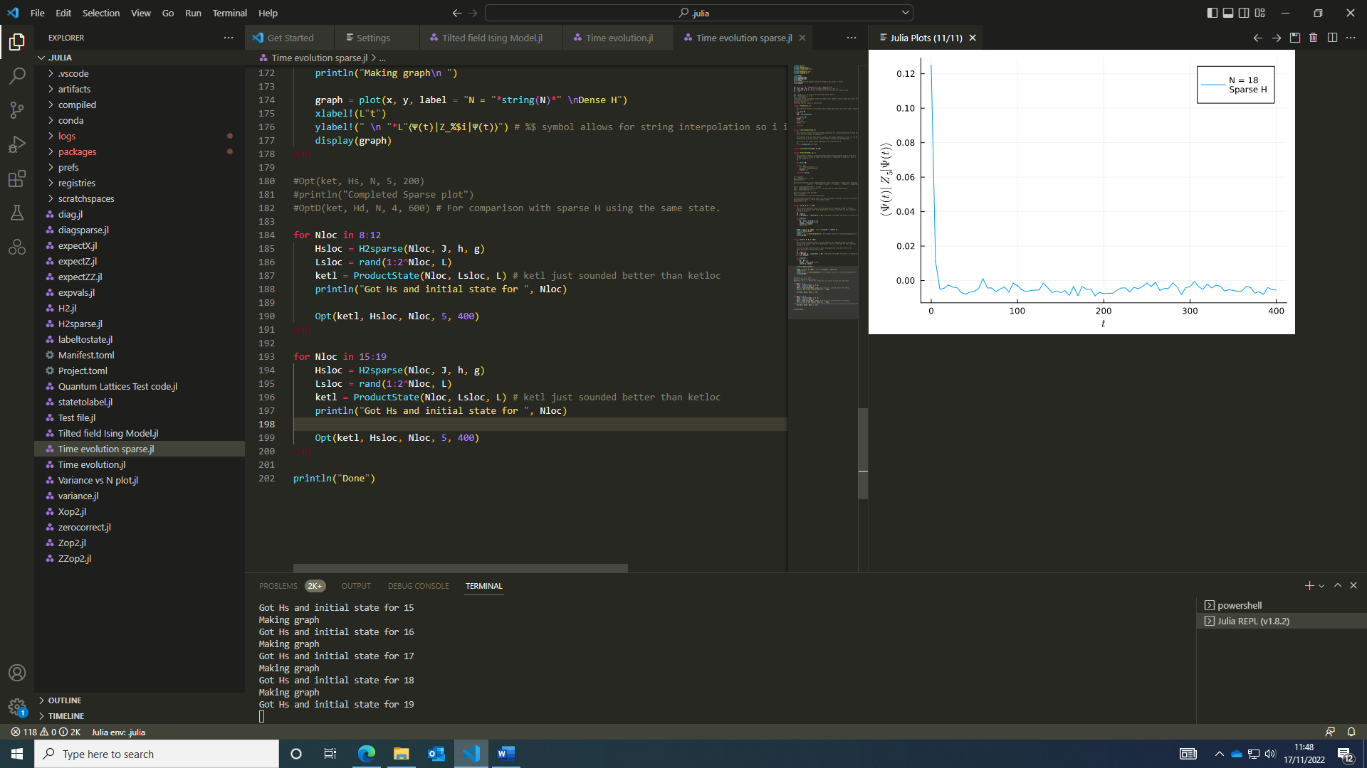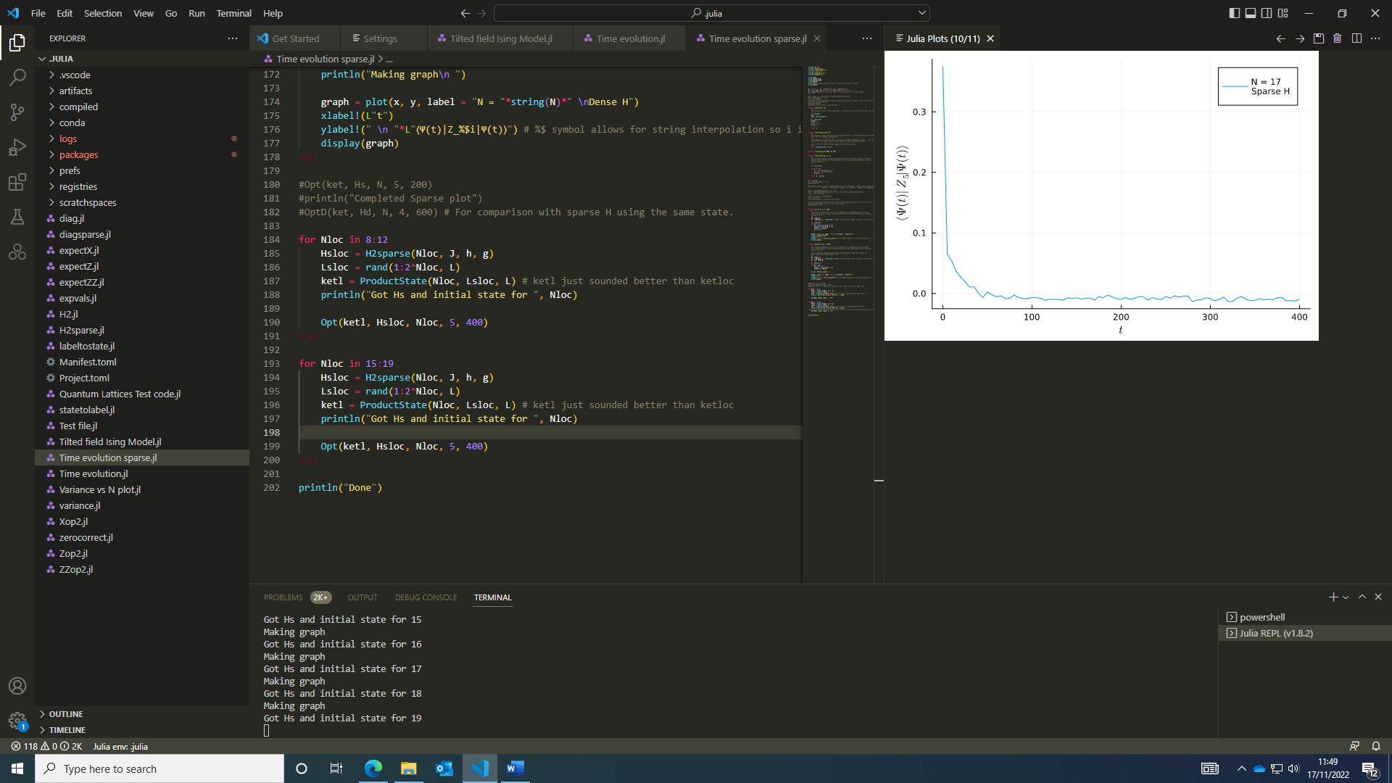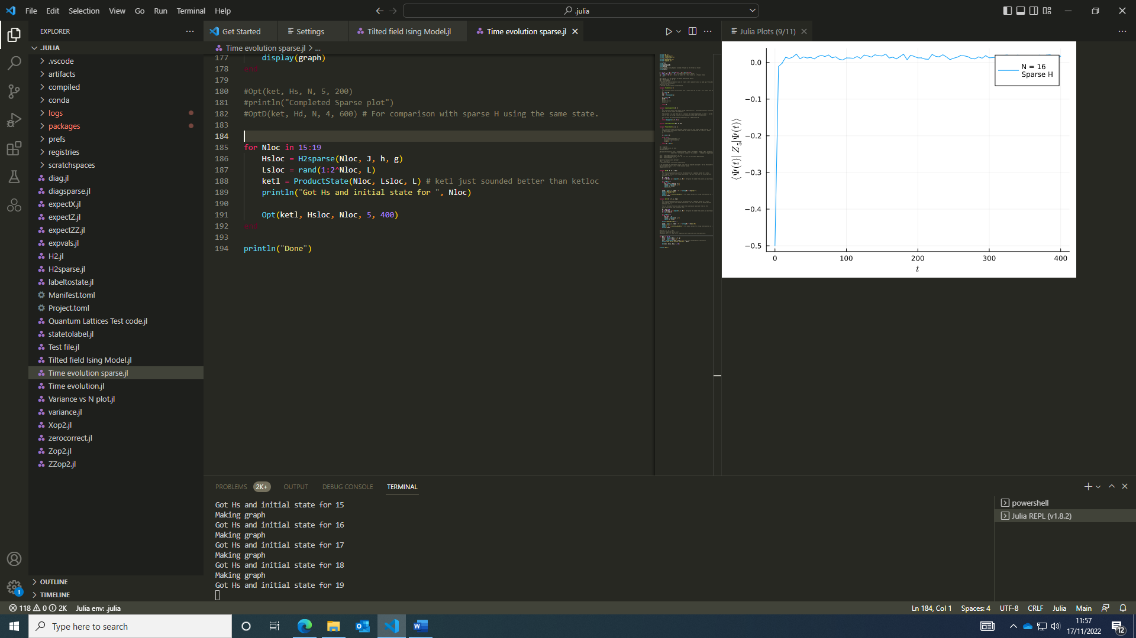The code ran overnight and produced some graphs for larger systems as I had hoped.

It would be beneficial to measure the fluctuations by calculating the variance after a time it appears to settle to a near-equilibrium value (I.e. the fluctuations of the long-time average). This could be done by calculating the variance of the second half of the expectation value array and printing the variance for each N, which can then be plotted to determine whether the fluctuations do indeed decrease with system size. The scales on the graph don’t give a conclusive indication of this so it would be helpful to quantify.

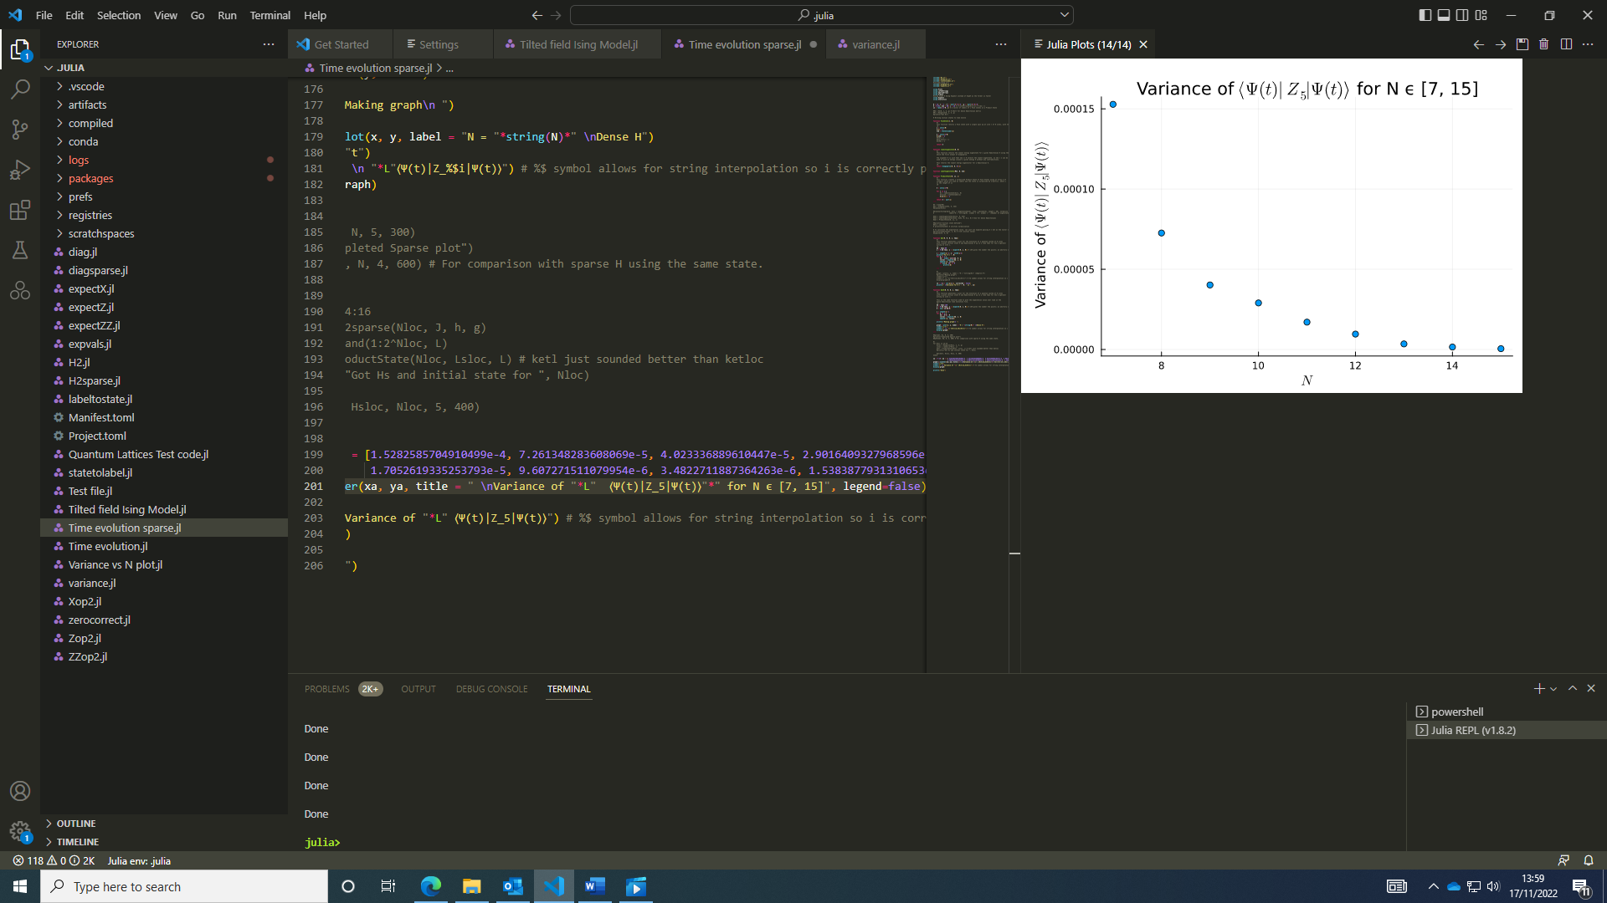I plotted the variance of the long-time fluctuations about a mean and found the variance appears to decrease exponentially with increasing system size in the range I looked at.

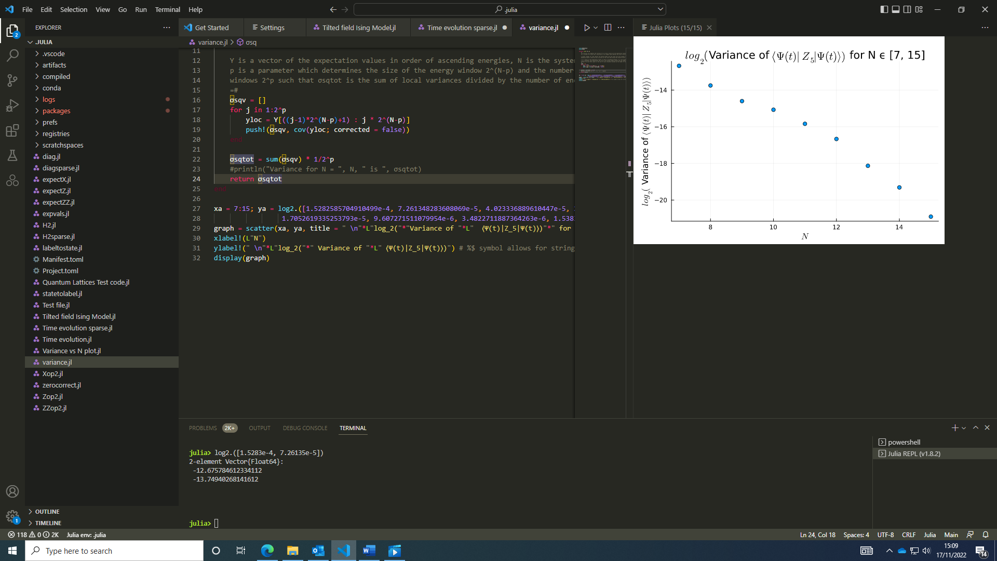A plot of log2(variance) vs N (log2(2N), the Hilbert space of the system with N sites) showed something more like a power law, possibly linear but N = 10, 11, 12 sit a bit off this trend.

Next, I made some modifications on how expmv function was implemented; now, the modified state is used after each step rather than including the step number in the argument and acting on the initial state each time and added the Fock state which was used to the graph title..

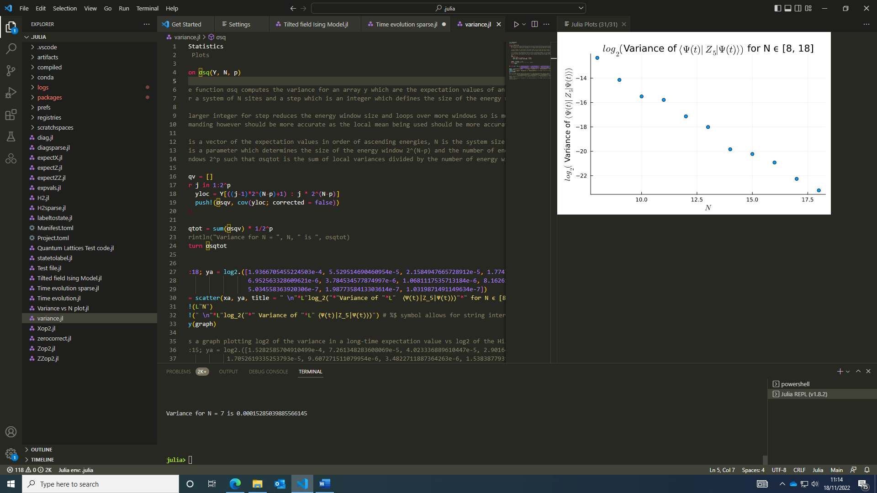

### 18/11/2022:

With these modifications, it was able to run quicker for larger systems so I attempted to measure the variance of the long-time average again and it showed a more linear dependence. I may run the code over the weekend to measure larger systems to see where the limit of the code is.

I tried running the code for larger systems, I found there was a limitation due to memory when I tried N = 24 but N = 20 run without producing an error.

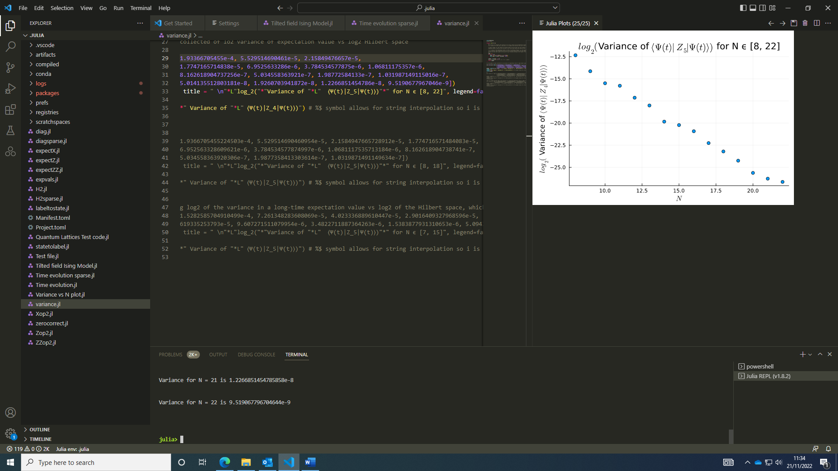I may try using a random Fock State rather than the same Fock State, however the long-time average fluctuations shouldn’t depend upon the state so this isn’t essential to do.

### 21/11/2022:

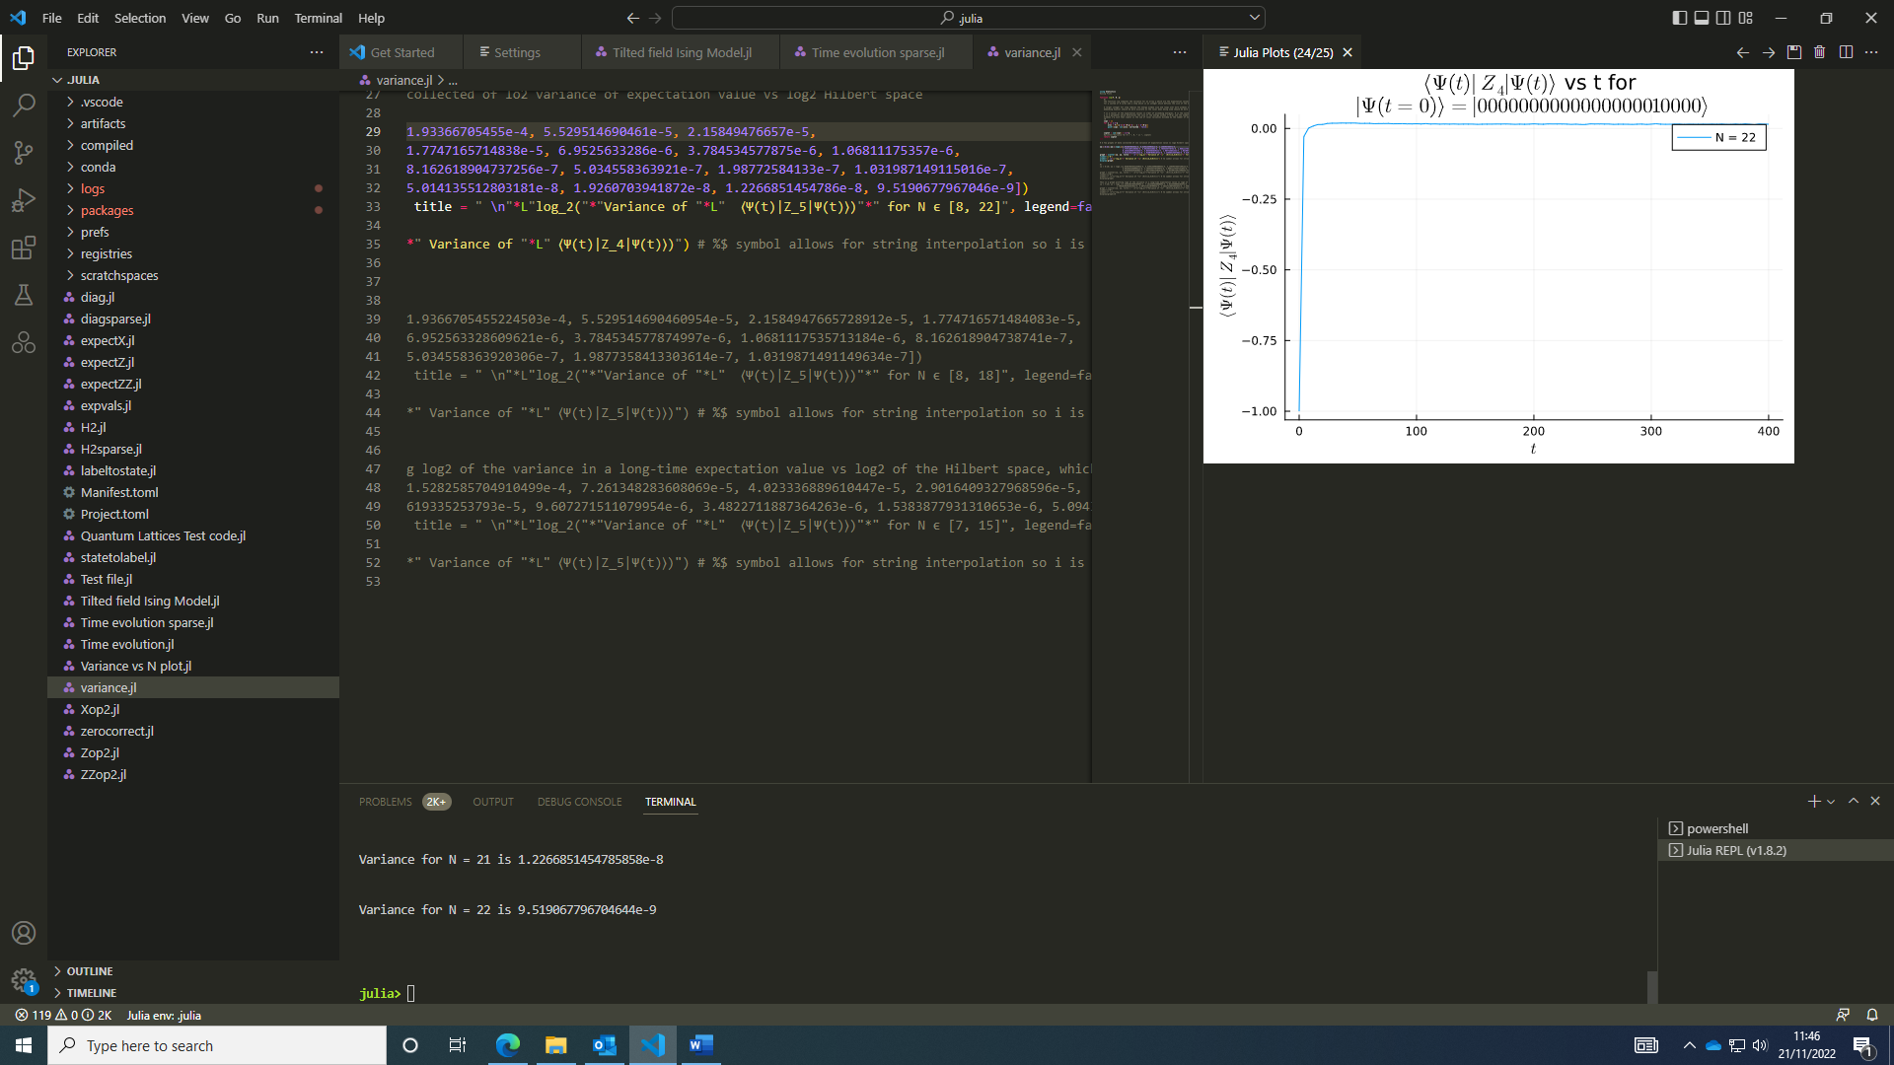I ran the code over the weekend to calculate larger systems and found the results today. The log-log plot of variance vs the Hilbert space of the system shows a linear decrease in the variance for larger systems as expected. The graph for the largest system measured, N = 22, can be seen left; the variance is very small, around 1 x 10-8.

I later ran some code overnight for N = 23 – 26 to verify the limit of the code with the changes implemented in updating the time evolved state so the exponent is only taken for a small increment each time.

I did look into calculating the entanglement entropy of a state; code used in my master’s project utilised the Itensor package and MPS features to quickly compute this (see the ITensor julia documentation [MPS and MPO Examples · ITensors.jl](https://itensor.github.io/ITensors.jl/stable/examples/MPSandMPO.html#Computing-the-Entanglement-Entropy-of-an-MPS)).

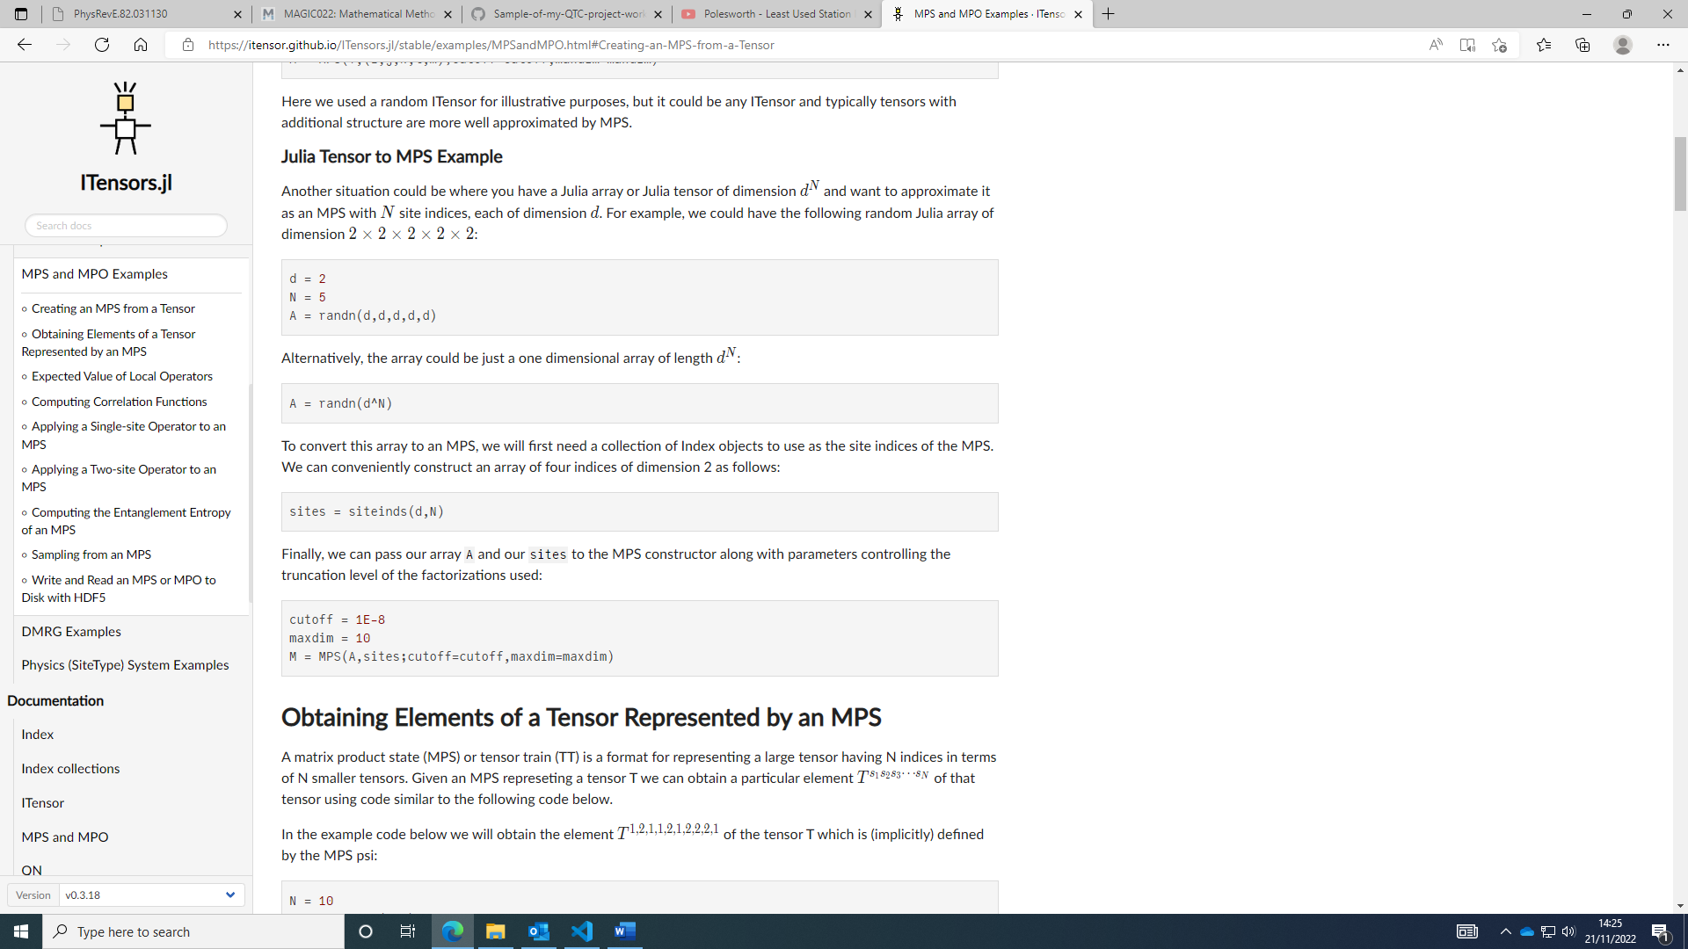As I’m working with julia arrays, I would have to convert each time evolved wavefunction into an MPS to measure the entanglement entropy as I’m not sure it would work to evolve an MPS in the current framework. This could be done by taking each vector as an array A, a 1D array of length 2^N.

Then, M can be used in the calculations of the entanglement entropy.

I wrote a function to calculate the entanglement entropy at different times (a time evolved wave function, a site and a sites index object are supplied as arguments).

I left some code to run overnight to measure the variance in entanglement entropy and the mean value as system size increases.

### 22/11/2022:

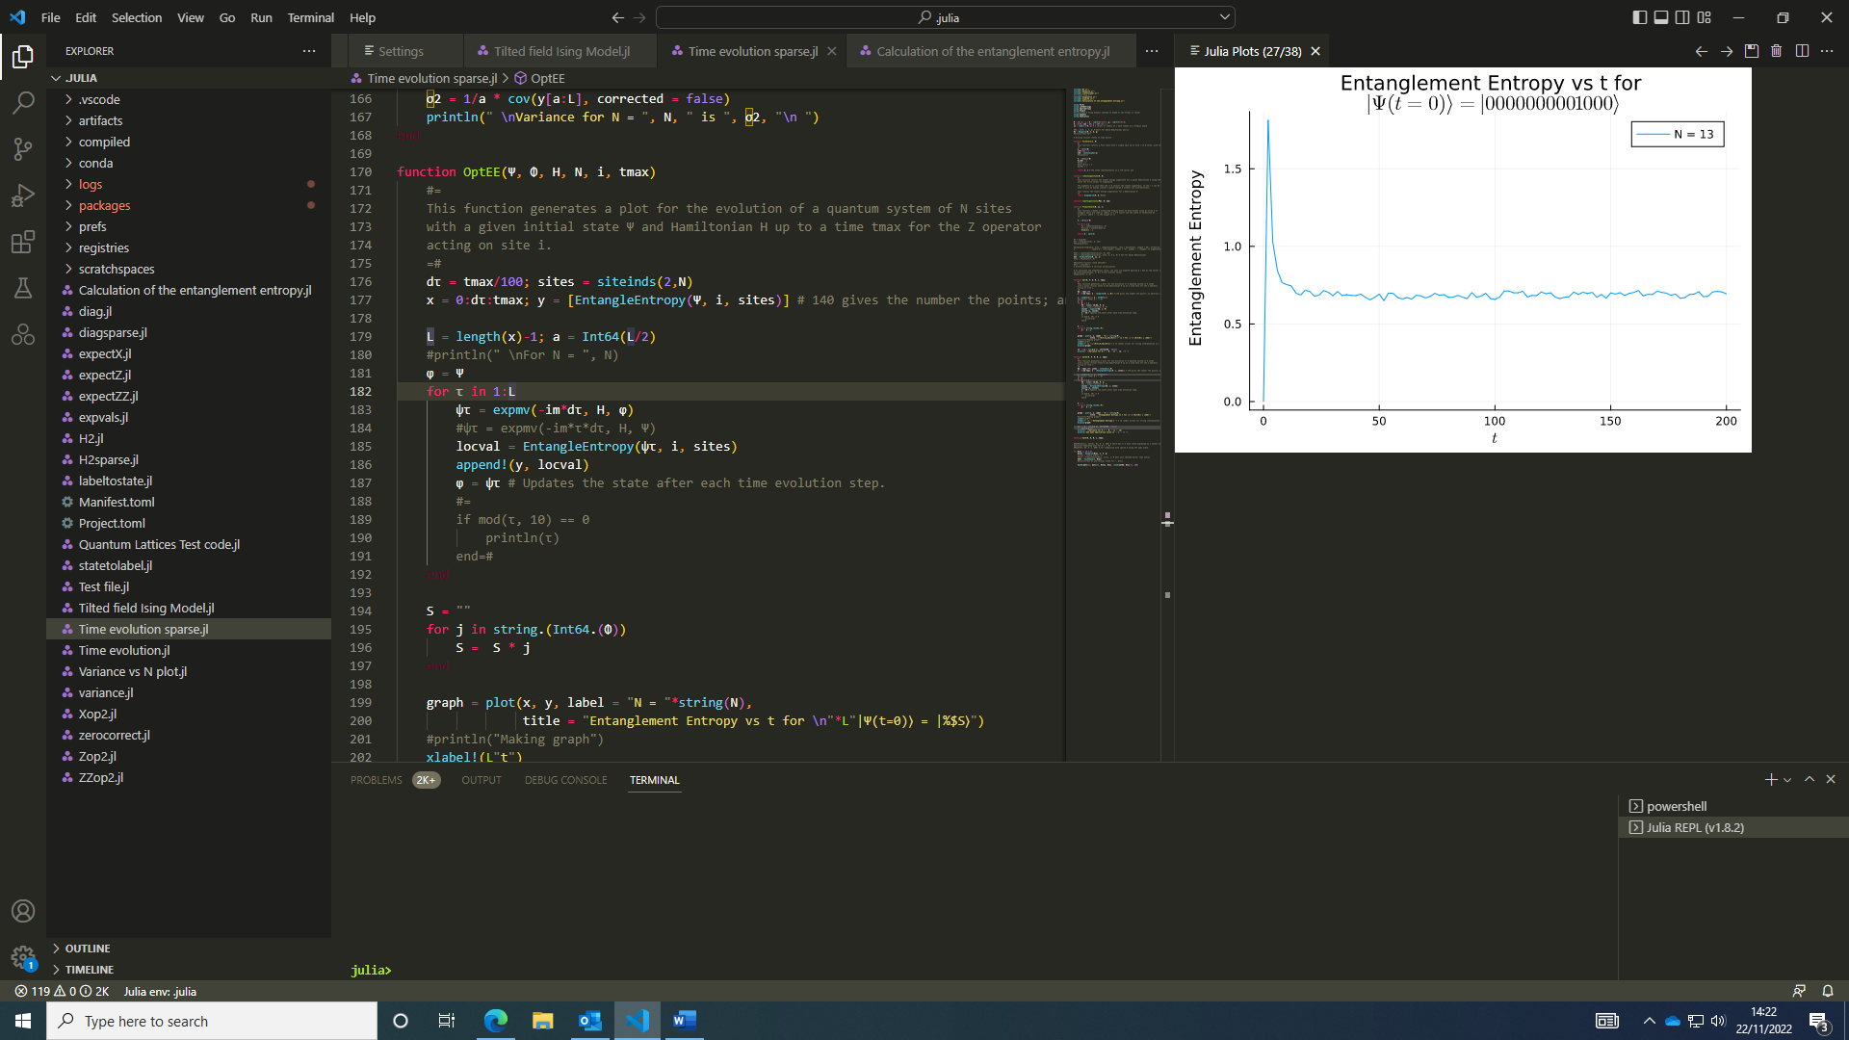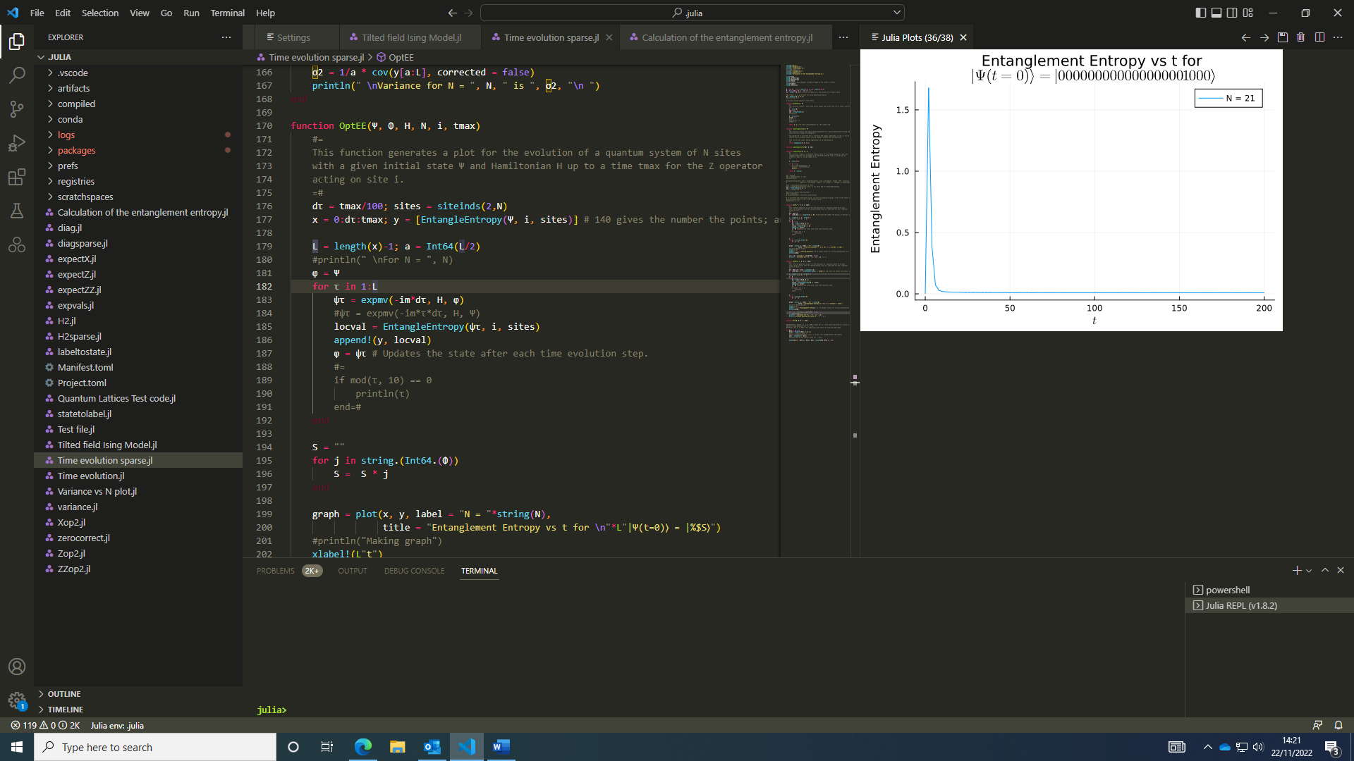I looked at the variance and mean values of entanglement entropy from a single Fock state and found the variance shrinks in system size and entanglement entropy gets smaller. The Fock State was $\left|\left.…01000\right\rangle \right.$. The entanglement entropy plots looked like:

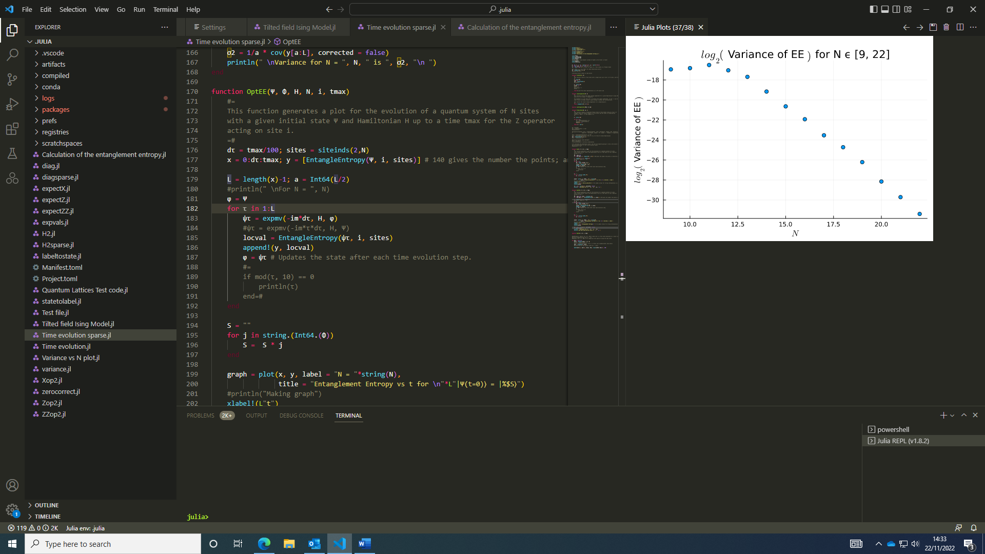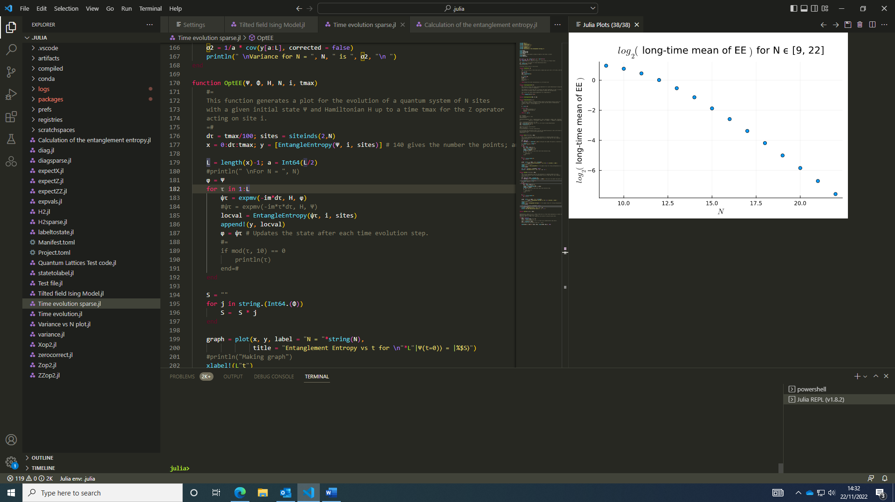The plot of the mean value and it’s variance for different Hilbert spaces (log-log in base 2) decreases for larger system sizes that were looked at.

After N = 12 - 13, this dependence of the mean value and variance decreases with a power law on the Hilbert Space of the system. For smaller system sizes, I suspect finite size effects make this effect less visible.

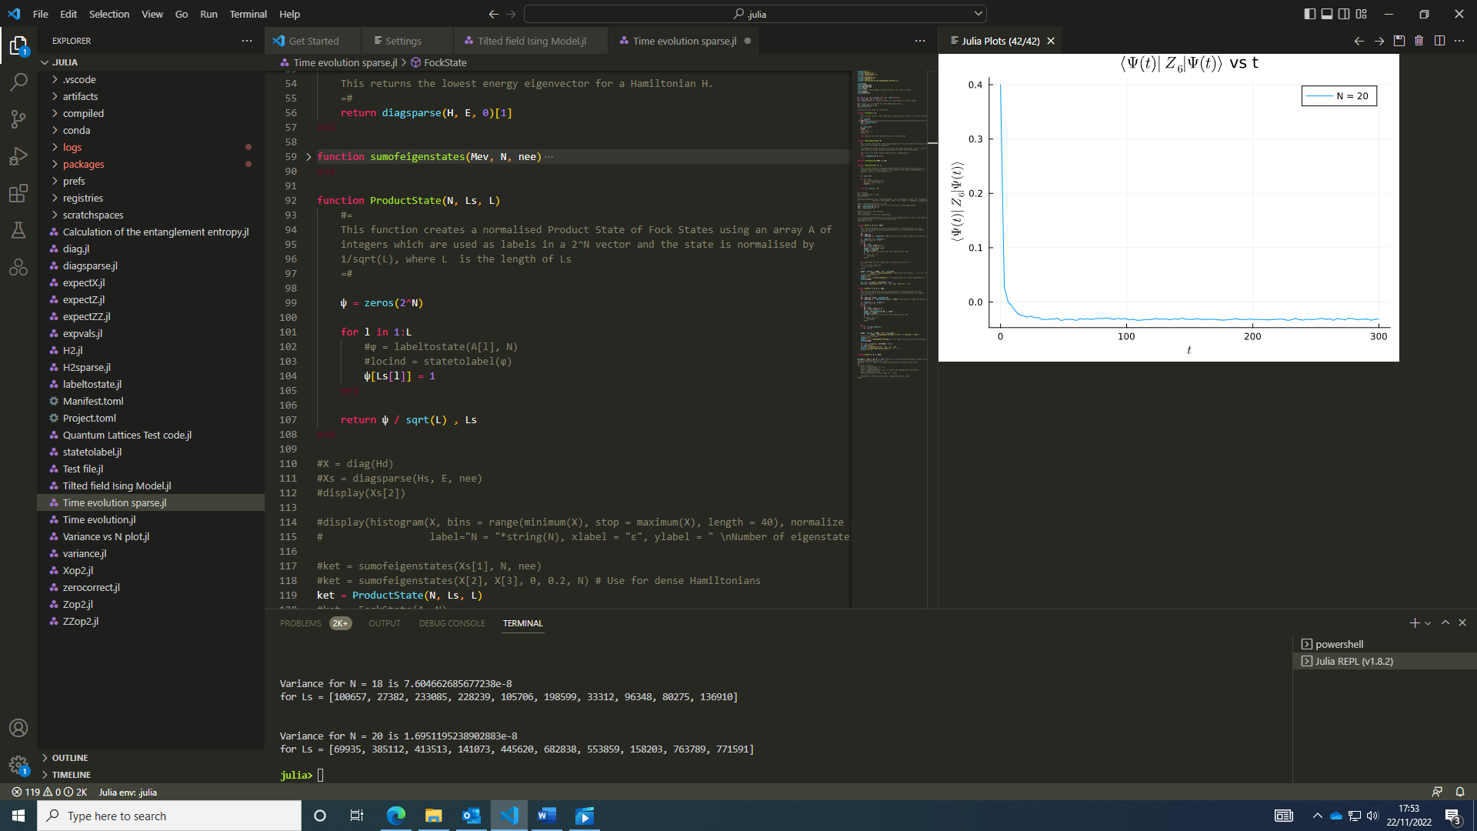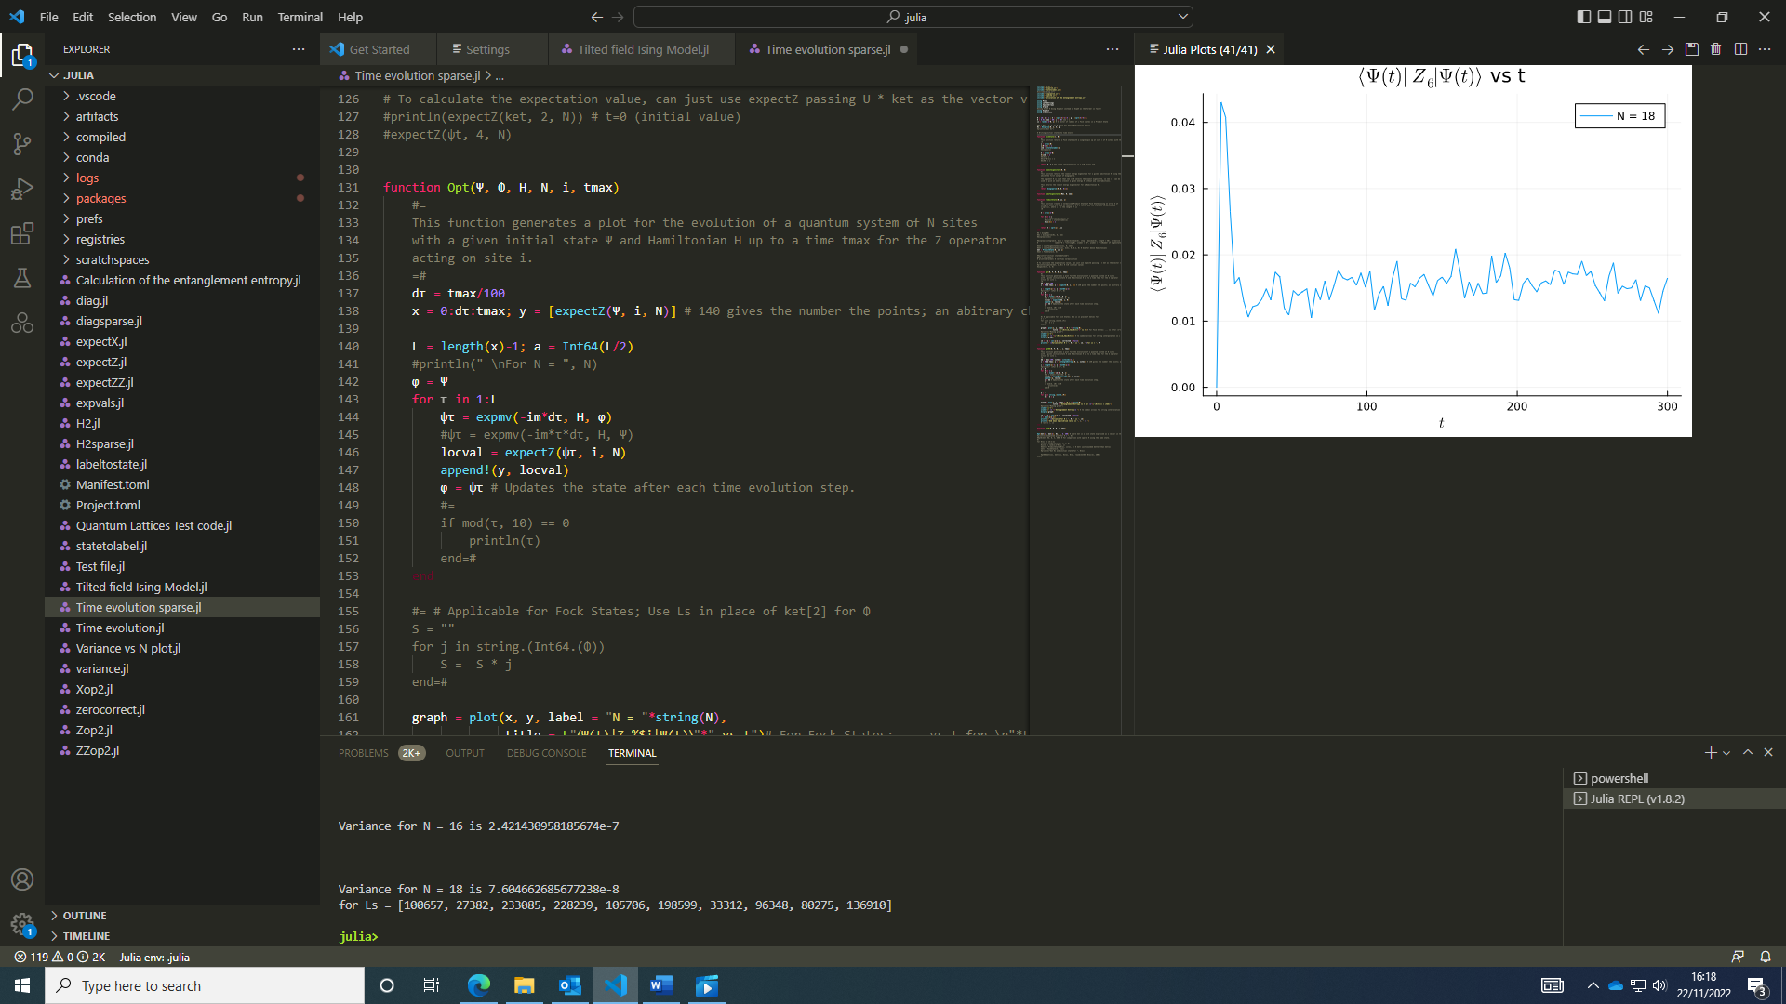It may be interesting to see the time evolution for a product state and how entanglement entropy varies when there’re more states involved (it could be identified by printing Ls array in the title). Note: The product state constructed is a superposition of the Fock states so isn’t an entangled state initially. I decided to look at a local Z observable and found similar behaviour to the Fock state evolution as one might expect. The state evolved here has the labels Ls = [100657, 27382, 233085, 228239, 105706, 198599, 33312, 96348, 80275, 136910]. The labels correspond to the state of this value (converted into binary to express the Fock State of the system) being a state in the superposition.

For N = 20, Ls = [69935, 385112, 413513, 141073, 445620, 682838, 553859, 158203, 763789, 771591]. The behaviour can be seen to be similar for different states and system sizes. The variance was 1.69512e-8, and the variance does decrease for larger systems as one would expect.

Later this week, I’ll look into ergodic properties of the model and read more about ETH and ergodicity.

### 23/11/2022:

Today I took a break from coding to focus on catching up with the MAGIC Mathematical Methods course. This involved a recap of complex analysis invovling Cauchy’s theorem, multivalued functions and Cauchy’s residue theorem.

### 24/11/2022:

Watched some more videos on Fourier and Laplace transforms.

In the afternoon, I did some reading around the topic of ergodicity. [6 equivalent ways of defining ergodicity - home (willierushrush.github.io)](https://willierushrush.github.io/posts/2022/02/ergodicity/#:~:text=The%20formal%20definition%20of%20ergodicity%20is%20usually%20taken,then%20either%20%24A_1%24%20or%20%24A_2%24%20has%20measure%20zero.), [Ergodicity - Wikipedia](https://en.wikipedia.org/wiki/Ergodicity). My current understanding is that ergodicity is when a system explores all states of a given parameter in a random manner.

After the meeting, I looked at the distinction between pure, superposition and mixed states.

### 25/11/2022:

A mixed state is an ensemble of pure/ superposition states. A superposition state may be a pure state so long as it satisfies the properties of the density operator (i.e. the trace of the density operator squared, the purity, equals 1 for a pure state). The density operator of a mixed state can’t be written as a single projector operator of a superposition state. This clarifies the difference between superposition and mixed states.

A system may be in a pure state which is entangled, so the subsytems can’t be described by a pure state.

The entanglement entropy of a pure state is zero by definition, since a pure state or product state can be described by its own projector and the entanglement entropy of a pure product state is zero.

### 26/11/2022:

Over the next few days, I read “Average Entropy of a Subsystem” and it proved the entropy of a subsystem for the whole system in a random pure state has nearly maximal entropy, for a subsystem much smaller than the whole system which gives no indication that the whole system is in a pure state; most of the information about the system is contained within correlations between subsystems. Although a pure state may be a product of pure states for each subsystem, it’s most likely that each subsystem is in a mixed state (there’re correlations with the other subsystems) as this maximises the entropy of the subsystem and hence the entropy of the whole system.

### 28/11/2022:

I took the code written in python and translated it into Julia. This took some time to get it working smoothly due to various errors popping up.

I also spent some time on the maths course, learning about the laplace transforms and an introduction to the Gamma function

### 29/11/2022:

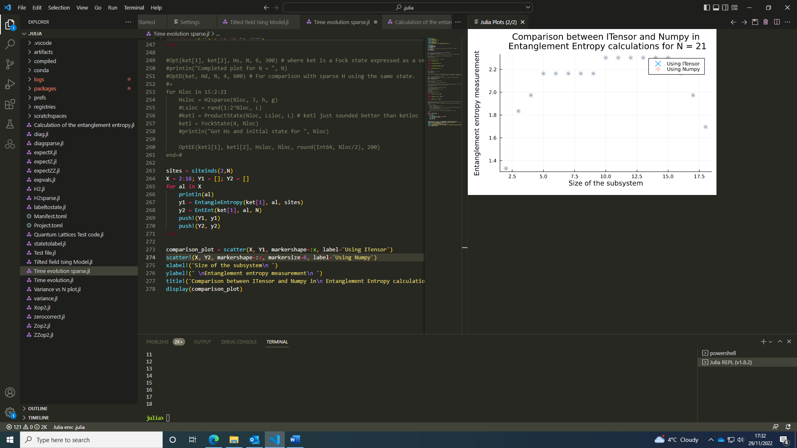With a short break from the code, I went back to it and managed to fix it. The 2 functions give the same results (up to 10^-15 so smaller differences are negligible due to computational accuracy) for the same parameters, so long as N is even so the system can be divided into 2 equally sized subsystems.

With these functions in agreement for even N and equally sized subsystems, I started to generalise the code using numpy for odd N and any subsystem sizes. This graph shows entanglement entropy values match for a wide range of subsystem sizes. The numpy code was faster than the ITensor code since it wasn’t converting the wavefunction into an MPS object for each time step.

### 30/11/2022:

I looked more at optimising the calculation of entanglement entropy function, and using the direct implementation of numpy, a python package, may not be as efficient as using equivalent Julia functions.